Flow of opening credits

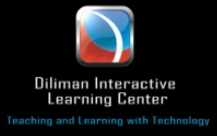

(DILC station ID)

<fade to>

(title of lecture)
(name of lecturer)

<fade to>

brought to you by the
Educational Consortium for Rural Development

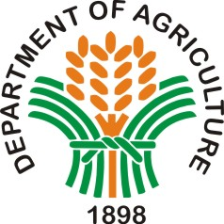







copyright 2012
Educational Consortium for Rural Development

<fade to video>

Flow of closing credits (scroll up)

(title of lecture)
(name of lecturer)

Educational Consortium for Rural Development

Department of Agriculture
Department of Agrarian Reform
Department of Environment and Natural Resources

Ateneo de Manila University
Development Academy of the Philippines
University of the Philippines
Xavier University

This video presentation is prepared by

UP Diliman Interactive Learning Center
University of the Philippines

copyright 2012
Educational Consortium for Rural Development

