PINAY DREAM

JANINE BIANCA MARIE PAGTANAC PAGUNTALAN

Submitted to the
COLLEGE OF MASS COMMUNICATION
University of the Philippines Diliman
In partial fulfillment of the requirements
for the degree of

BACHELOR OF ARTS IN FILM

APRIL 2013

PINAY DREAM

by
JANINE BIANCA MARIE PAGTANAC PAGUNTALAN

has been accepted for
the degree of BACHELOR OF ARTS IN FILM
by

Professor Olivia Linsangan Cantor

Professor Rolando B. Tolentino, PhD
Dean, College of Mass Communication

BIOGRAPHICAL DATA
PERSONAL DATA
Name Janine Bianca Marie Pagtanac Paguntalan
Permanent Address 17 Malanting St. Amparo Subdivision, Caloocan City
Telephone Number (+63927) 921-8152
Date & Place of Birth 13 July 1992, Makati City
EDUCATION
Secondary Level Crescent Wood Learning Center
School of the Holy Spirit of Quezon City
Primary Level School of the Holy Spirit of Quezon City
ORGANIZATION Member, UP Cinema Arts Society (2011-present)
WORK EXPERIENCE Intern, ABS-CBN Star Cinema April-May 2012
Crew, UPFI Film Theses: Lakas, Wanderscape
ACHIEVEMENTS College Scholar
(1st Semester AY 2009-2010, 2nd Semester AY 2012-2013)
University Scholar
(1st Semester AY 2012-2013)
ACKNOWLEDGMENTS
The filmmaker would like to extend her sincerest and heartfelt gratitude to the following people for their assistance, encouragement and unwavering support in making her thesis production, Pinay Dream a success:
Her parents, for all their love and support, for believing in her capabilities to be able to direct this film and for keeping her strong and optimistic;
Prof. Olivia Linsangan Cantor, the filmmaker’s thesis adviser, for her many contributions and improvements in the film, for her encouragement, support and trust, and for firmly standing by the filmmaker during the thesis defense;
Prof. Grace Alfonso, the filmmaker’s thesis proposal adviser, for her help in the initial development of the story;
Zenobia Abiera , for all the time and effort she has contributed in order to give depth to the characters and develop the narrative;
Ging and Jay Paguntalan, the filmmaker’s siblings, for the love and encouragement, and for always believing in her;
Duane de Mesa, for being a very avid supporter, stress reliever and inspiration, and for all the pep talks that helped the filmmaker push herself to do her best;
Ate Helen, Raquel, Jovie and all the ates and kuyas for helping the filmmaker finish her thesis, for all the sleepless and stressful nights and days, for helping her find a sound editing studio, for being the inspiration for this film and for standing by the filmmaker and her message until the end;
Celina Donato, Ariadne Villanueva and Tara Llavore, for being her thesis buddies, for answering all the filmmaker’s inquiries and for all their help;
Marife Necesito, Chris Perris, Isadora Villasquez, Elle Velasco, Tess Gonzalez, the cast of the film, for their amazing performance and for their patience and understanding;
Gert Mansos, for being the most amazing editor, colorist and production designer, for doing a great job amidst the filmmaker’s haggard and stressful demands;
Leandro Lorenzo, for being an amazing cinematographer, editor and best film friend, for his very hands-on contributions and for believing in and defending the filmmaker and her film;
Ana Lou Sanchez, for being the best assistant director, from handling the actors to the scheduling to her calm and collective directing, for all her efforts that are certainly very much appreciated;
Nicki Dans, for being a big sister, for all the advice and help, for being a great production manager, for all her encouragement;
Lou Mendoza, for all her help in making the film, for the support and help, for making the storyboard even if it was not used;
Kai, Ron and Jonah, for being the small but terrible production design crew, for looking for all the props that were very hard to find, for all their time and efforts in setting up and setting down, for their time and effort;
Dada and Chantal, for the great wardrobe and make-up, for entertaining and taking care of the actors;
Tiara and Miguel, for all their efforts and help, for providing the crew a fun shooting experience, for being the best girl and best clapper, respectively;
Henry and David, for being the best sound couple, for providing great comic relief in the stressful production;
Kuya Aga, Roldan and Leklek of RSVP Studios, for providing such great company, for the awesome lighting and conversations during the shoot;
Jessica David, for making the Pinay Dream poster;
Kuya Jec, Mr. & Mrs. Diwa of Soundweavers Recording Studio, for helping with the sound design even at short notice;
The crew of Pinay Dream,for all their time, effort and support all throughout making the film and even after the defense;
The UP Cinema Arts Society, for providing the filmmaker with a great set of film friends, crew, and for all their time, effort, love and support;
And everyone who helped the filmmaker make Pinay Dream a success.
ABSTRACT
Paguntalan, J. P. (2013). Pinay Dream, Unpublished Undergraduate Thesis,
University of the Philippines College of Mass Communication
Helen, a poor salesgirl from the Philippines, dreams of someday marrying a foreigner. She believes that with Fil-American or Amerasian features, doors will open for a lucrative and successful career in acting or modeling for her future offspring. Their beauty will provide them hope for a secure financial future. She meets John thru on-line dating, an American businessman, whom she marries after a brief courtship. She then migrates to the U.S. with John. Helen encounters extreme disappointment, difficulties and challenges brought about by her marriage and new surroundings.
The character of Helen centers on the feminist film theory. This theory espouses the promotion of social, political, monetary and artistic equality between men and women. The issue of traditional gender roles plays an important part in the story since John, a strict patriarch, forces Helen to become domesticated-a plain housewife. However, Helen herself desires to forge a career outside the confines of their home in order to achieve financial independence from John. Issues of gender stereotyping and patriarchy will also be depicted in the film.
Helen’s dream to marry a foreigner is grounded on the postcolonial theory. There is continuation of colonialism by means of economic, social, cultural and linguistic influences by the colonizer, long after independence has been attained by the colonized. This colonial mentality is manifested by our standard of beauty, wherein Caucasian features are deemed more beautiful than Filipino and Asian looks.
TABLE OF CONTENTS
Page
Title Page i
Approval Sheet ii
Biographical Data iii
Acknowledgements iv
Abstract vii
Table of Contents viii
- INTRODUCTION 1
- REVIEW OF RELATED LITERATURE 6
AND CREATIVE WORKS
- STUDY FRAMEWORK 13
- METHODS AND PROCEDURES 19
- SCREENPLAY 27
- SCREEN CAPTURES 47
- FACULTY CRITIQUES & RECOMMENDATIONS 51
BIBLIOGRAPHY 55
APPENDICES
- Thesis Proposal 57
Sample Production Materials
- Call Sheets 96
- Sequence Breakdown 100
- Permits and Receipts 102
- Thesis Defense Forms 109
Production Stills
- INTRODUCTION
.
Pinay Dream is a story about Helen, a 28 year-old saleslady from Manila. She is the sole breadwinner of her impoverished family. Very hardworking and fiercely independent, she also takes on other odd jobs to augment her income. She started working outside the home at a very young age. Helen aspires to someday alleviate herself and her family from abject poverty. Her Aunt Ester, who has achieved a better life working in the United Kingdom, has become her role model. She dreams not only of working abroad but more specifically of marrying a foreigner. Being a romantic and an idealist, she desires to develop a loving relationship with her foreigner husband and to eventually have the beautiful children she is most obsessed with. Her penchant for Caucasian-looking children stems from the standard of beauty perpetuated by media. Media glorifies Filipinas with Amerasian features who dominate the financially rewarding movie, modeling and advertising worlds. This perception further reinforces her desire to marry a foreigner and thereby produce socially and physically desirable children.
In order to attain her dream, Helen utilizes social networking via the internet. She eventually meets online a prospective husband in the person of John. John is an elderly American businessman, a workaholic. He works long hours and has little time to develop interpersonal relationships on a face-to-face basis. He resorts to meeting Asian women online, to fit into his busy schedule. His predilection for Asian women stems from his belief that they are traditional homemakers, domesticated, loyal and subservient to their husbands.
In the course of only two months, Helen and John get to know each other superficially. They develop a relationship via online chats, rigidly scheduled by John. The sudden arrival of John in the Philippines and his unexpected proposal of marriage surprises Helen. She readily agrees to marry John after their whirlwind web-based courtship and settles down with him in the United States.
Not having known each other on a more personal basis, each of them had unexpressed expectations for their relationship. Helen has always dreamt of having beautiful Caucasian-looking children early on in her marriage. Being young and a romantic, she expects a loving intimacy with a husband who would spend quality time with her. She seeks purpose in a fulfilled life with a loving husband and beautiful children. However, the thought of helping and providing for her family in the Philippines is still in her list of priorities. John on the other hand is elderly, set in his ways and a workaholic. In this late stage of his life, he desires to have a wife who will be a homemaker (someone who will be content to clean, cook and tend to his needs) and a companion. He is not desirous of having children with Helen. He chose a wife like Helen who belongs to a lower socio-economic class, whose family he will help support financially, believing that in so doing she will be indebted to him. This indebtedness of Helen will allow him to manipulate and dominate her.
In the course of the story, it is proven true that marriages wherein partners have divergent expectations eventually fail. Helen was unsuccessful in her attempts to develop a close personal relationship with her husband, since they did not have quality time with each other. Her adjustment to a totally different environment and culture did not help the marriage either. Faced with a new environment without the emotional support of a loving and understanding husband, Helen felt totally alone. To compound the problem, Helen who has started working outside the home at a very young age, felt constricted in her new role as a domesticated housewife. Her desire for financial independence in order to personally support her family in the Philippines was stifled by John. Furthermore, her natural craving for a satisfying sexual relationship was unmet by her elderly, workaholic husband. But most importantly, her obsession to have beautiful Caucasian-looking children became impossible.
With all these factors stacked against her, Helen felt she had no recourse but to return to the Philippines. Helen’s decision to go back home instead of trying her luck in the U.S. is a typical attitude of some Filipinas who run back to their families when faced with stressful situations and problems. More specifically, since a failed marriage weigh heavily on most Filipinas who put a high premium on the sanctity of marriage they often rationalize that family togetherness and shared hardships are better options than prosperity away from one’s home, loved ones and country. However, there are also those who choose to remain in a foreign land, endure oppressive relationships away from home, in exchange for material gains and a fruitful career. These show two facets of the Filipina – those who choose to remain in a foreign land for pecuniary reasons and career advancement despite disappointments; and those who choose to go back home, accept the failure of a dream and utilize said failure as a driving force to aspire for a better life in their own country.
The main idea for this thesis concept came from eavesdropping on the day-to-day conversations of our house helpers regarding their hopes for the future. Even as a kid, I have been privy to the secret longings of my own nanny to meet and eventually marry a foreigner. I would frequently hear her and our other house helpers talk about their love lives, their boyfriends, and their longing to meet foreigners. Time and again they have expressed their dreams and their desire of someday meeting and marrying a foreigner who will rescue them from a life of poverty, but most importantly who will give them children with Caucasian features. My nanny shares this hope with the saleslady in the department store, the grocery girl behind the counter, and many other Filipinas. Most of them resort to online correspondence with foreigners to achieve said dream. Thus, through Helen, I aim to discuss the phenomenon that is commonly happening today-the Filipina mail-order bride.
Mail-order brides are defined as “women who list themselves in catalogs (online or otherwise) and is chosen by men for marriage” (“Mail order Bride Law & Legal Definition”). For the purposes of my paper, mail-order brides will be loosely defined as women who seek marriage with foreign men through internet-based meeting sites. These women generally come from impoverished areas in Asia like the Philippines (“Mail-Order Brides: The International Buying and Selling of Women”)
Some view the preponderance of the mail-order bride phenomenon as a form of greed and exploitation. Critics label mail-order brides as ambitious social climbers and money greedy harlots who would settle for a marriage of convenience, a loveless union, in exchange for a better life or for monetary gain. This film hopes to paint a different picture in the person of Helen. Unlike other Filipina mail-order brides who only marry foreigners for financial reasons, financial gain was only secondary for Helen. What she desired most was to have beautiful Caucasian-looking children with a husband she could love and who would eventually love her. There was effort on her part to make love grow between her and John. She epitomizes the hundreds and even thousands of Filipinas who are willing not only to sacrifice themselves to help their impoverished families but who also strive to make their marriage work with a foreigner spouse.
I wish to present a deeper understanding of the Filipina’s sense of loyalty not only to the families they leave behind in the Philippines but likewise to the men they marry. This strong sense of loyalty enables them to get past cultural differences and would account for a significant number of happy marriages some of these mail-order brides eventually establish. Helen’s character went to great lengths to better her self in order to be worthy of John. She tried her best to be a good housewife and a future mother. Had the circumstances been different with John, Helen’s story might have ended happily.
To sum it up, this film portrays the longings and aspirations of a segment of the modern Filipina in our society. It touches on the unconventional means they take in order to achieve their dreams and the possible consequences of said actions.

- REVIEW OF RELATED LITERATURE AND CREATIVE WORKS
- Closer to Home by Joseph Nobile (Elibon Film Productions, 1995)
This film tells the story of Dalisay, an underprivileged seventeen year-old Filipina who lives in the province, and her journey to New York City to marry Dean, an ex-merchant marine coming from a lower-middle class family. She sees Dean as her passport to the land of milk and honey. She believes that marrying Dean and living in the United States will help her afford a cure for her dying sister and eventually give a better future for her debt-ridden Filipino family.
Dalisay’s actions in marrying Dean stem from her desire to obtain financial support needed for her sister’s heart surgery and to ultimately help give her family a better life. Dalisay’s outlook in life provides comparison and contrast to the goals, decisions and choices made by Helen after she married John. Their reasons for marrying a foreigner are parallel in the sense that both dream of having a better life and a more secure future. While Dalisay leans towards financial dependence on Dean, Helen was desirous of financial independence by insisting to John that she wanted to work. She wanted to be able to support her family in the Philippines financially herself as she has always done in the past. However, both see marrying a foreigner as a way of escaping poverty, i.e., in the case of Helen, she believes that having children with Amerasian looks and features will open opportunities for movie and modeling careers for her future children with John.
Dalisay and Helen portray two different personalities of a Filipina. Dalisay represents the conservative, subservient and domesticated Filipina who is happy with the role of just being a simple housekeeper, wife and mother. She unquestioningly and contentedly relies on her husband for full financial support. Helen, on the other hand, represents the new breed of Filipinas who are proactive, modern in their outlook and more assertive in the kind of role they want to play, be it in marriage, in their respective careers and in society in general. Had Helen been content in playing the role of a conservative and simple housewife like Dalisay, her marriage to John would have survived. Differences in expectations, coupled with Helen’s modern outlook and John’s conservative and stereotyped way of thinking combined to doom their marriage.
- Say I Do by Arlene Ami (Red Storm Productions, 2003)
This documentary film archives three stories of mail-order brides from the Philippines currently living in Canada. These three women married men they did not know to escape poverty and to be able to help support their families. When they arrived in Canada, they resided in isolated areas of the country. One woman discovered the violent side of her husband. These women did not know anybody in their area aside from their husbands. They said that their husbands were “men who searched for women with traditional family values, and were unsuccessful with Canadian women whom they felt had many freedoms and were spoiled.”
The description the mail-order brides gave their husbands was what John expected from Helen. He is under the impression that all Asian women possess these qualities. He expects them to be passive women unlike their western counterparts. John discerns that marriage to a Filipina will last and not end in divorce since, if media stereotypes of Filipinas are to be believed, he would not have to contend with the fiercely independent and “rebellious” streak of Western women.
However, to John’s disillusionment, Helen belongs to the new breed of Filipina women who are modern in their views and outlook and are capable of asserting themselves. It was a stroke of fate that John missed meeting the more conservative Filipina type who would have happily traded financial and career independence in exchange for a simple and domesticated life, as wife and housekeeper to a foreigner husband. If only fate intervened in John’s favor, because there are still a substantial number of these conservative Filipinas who would have completely met his needs and expectations, he would have met his perfect match. Sadly, John failed to meet the right “Filipina match” in Helen. His marriage would have been a success if he happened to have met a conservative Filipina who like him was no longer desirous of starting a family.
- Romance on a Global Stage: Pen Pals, Virtual Ethnography and “Mail Order” Marriages by Nicole Constable (university of California press 1 edition September 18, 2003 293pp)
In this book, Constable discusses the image of women who are labeled as mail-order brides and states that they are less fairly represented, less well understood and at a disadvantage in showing their perspectives as compared to the men who marry them.
Mail-order bride catalogs Oriental women as the opposite of their liberated western feminists. Asian women are portrayed as those who dream of meeting and marrying someone rich and powerful, who will free them from poverty. While the American men are portrayed as those who dream of meeting and marrying passive, obedient, non-threatening, virginal women who will devote their entire life serving them and making no demands. Asia is also depicted as a site of patriarchal fantasy for men who feel that male pre-eminence in the family is being undermined.
Out of the 40 mail-order brides Constable interviewed each from China and the Philippines, findings stated that most of the women from the Philippines used internet cafes to communicate with possible foreign husbands and that they came from rural areas. Several of the Filipinas belonged to the lower socio-economic class as compared to the Chinese women who were, i.e., nursery-school teachers, shop clerks, domestic helpers, factory workers and waitresses.
In her interviews, she found out that women made informed decisions and that they were very much aware of the dangers that they might face. It was also revealed that mail-order brides refuse to acknowledge they are “selling” themselves. Instead, they believe that they assume active roles in the courtship process of mail-order marriages.
Constable asserts that not all mail-order marriages have a destructive relationship and not all foreign husbands resort to physical abuse. However, she acknowledges that inequalities between partners in this marital transaction may in fact lead to exploitation since the male spouse may feel that he is superior to his mail-order bride and that he has “bought” her. Constable quotes Roland Tolentino in the representation of mail-order brides as the foreign man’s colonialist fantasy or racial conquest and rescue. Constable points out further that the women should be correctly portrayed to show how they assert dignity and express strength instead of being a passive sex object and a submissive wife, since the current inaccurate representation, risks catching the attention of abusive men.
The character of Helen establishes her motivations and aspirations in marrying a foreigner, that is, to be able to provide a good life for her family and her future offspring with her foreigner husband. It is shown that her socio-economic background plays an important role in her decision to marry a foreigner. The role that media plays by showing Filipinas with Amerasian features dominating the movie, modeling and advertising world influences her goal to marry a foreigner. Her choice of a husband is further reinforced by an aunt who has cultivated a successful and loving relationship with her foreigner husband.
Her actions present a character that assumes a proactive role in the courtship despite being warned of the disappointments or dangers such a relationship could bring. Helen’s character highlights deeply ingrained Filipina virtues-loyalty and devotion to husband and family, sincere desire to make a marriage work and commitment to a love and marriage that will last forever. Thus, while marriage may initially be embarked on as a marriage for convenience or based on financial considerations, Helen’s character shows that through the natural Filipina virtue of a sense of commitment, she musters the effort to make love grow out of the seemingly “mercenary” relationship. However, Helen’s failure as a wife in John’s eyes is her modern attitude towards the desire to combine marriage, career and financial independence. She was not content to solely lean on her husband for her financial needs. She is not agreeable to a subservient, domesticated role of a wife, as expected of her by John. Cultural differences where child bearing is concerned as well as Helen’s ineptness to easily adjust to her new environment further wrecks havoc on their marriage. The final wedge that split their marriage apart was their failure to meet each other’s “preconceived notions and expectations” based on media stereotypes of traits to be expected of Filipinas, as well as of American men, respectively.
- Picture Bride by Kayo Hatta (Miramax Films, 1995)
This film talks about the story of Riyo, a 16 year-old city girl from Japan. When her father died, she was forced by her aunt to become a picture bride. She was to undergo an arranged marriage with Matsuji, a farmer in Hawaii. The two of them met and she finds out that he was significantly older than what the picture has shown. Riyo and Matsuji are married and they travel to their home in the sugar plantation. Riyo fights off Matsuji’s attempts at intimacy. She did not want to be married to Matsuji so she decided to save up money to move back to Japan. Unfamiliar with farm work, she is harassed and ridiculed by the field supervisor. She starts working harder and taking on extra work to be able to save up from the small wages that is given to them. Riyo develops a friendship with Kana, a co-farmer. Kana advises Matsuji to start being romantic to Riyo to win her heart. The field supervisor drives the workers to do more work to meet the crop in time. The farmers who have children are constantly worried about their children who are left while they are working. Kana asks the field supervisor to have their children closer to the workers when they transfer to another field. The field supervisor threatens to whip the workers when Kana tries to stand up to him. When the cane fields are set on fire, Kana realizes that her kid is nowhere to be found. She tries to find him in the middle of the burning field and both are lost. The workers talk about waging a strike. Riyo assumes leadership on the field, replacing Kana.
Riyo and Helen married men they were not familiar with. Both of them migrated to foreign countries in the hope of a brighter future. Like Riyo, Helen married an elderly husband she hardly knew. She did not find the romance in the relationship she was hoping for. Being young, she expected a more romantic relationship with John. As in the story, Kana advised Riyo’s husband to be more romantic to his wife in order to win her heart. John did not exert any effort to romance Helen. Another similarity between Riyo and Helen is their strength of character. Their actions depict them as strong, independent and empowered. Riyo assumed the leadership of the worker group upon the death of Kana. Helen, on the other hand, assumed control of her life. Both Riyo and Helen remained in command of the situation and rose above the odds.
- Shattered Glass by Billy Ray (Lion Gate Films, 2003)
This film talks about the story of Stephen Glass, a writer at the in-flight magazine of the Air Force One called The New Republic. Stephen Glass is first seen giving a talk to a bunch of students in a classroom in his old school. There, he tells the students how he got a spot at the magazine. The film shows a flashback of Stephen Glass as a writer. The flashback showed his experiences as a writer and the journalistic fraud that he has committed. The film bounces back and forth from the present time to the flashbacks. The classroom scene is shown again. Stephen is standing in front of the empty room. The story ends with Stephen being fired from his job that resulted from his 27 articles that were fabricated in whole or in part.
The form and presentation of Stephen’s story makes use of the present, as well as introduction of flashbacks. This technique has been adapted to portray John and Helen’s story. To be able to provide a holistic picture of Helen’s relationship with John and to enlighten viewers regarding the basis for the decisions and choices made by Helen with regards to her relationship with John, a glimpse of her present life with John in the U.S. is first shown. Then, her impoverished background is depicted as a flashback to be able to provide a better understanding of Helen’s nature. Back to the present plane, John and Helen’s differences are shown to provide the needed explanation for their eventual separation and divorce.

- STUDY FRAMEWORK

Post-colonial
The Post-colonial theory is relevant to this film in its contention that there is a continuation of colonialism by means of economic, social, cultural and linguistic influences on the colonized long after the mother country has left (Childs & Williams 3). The Philippines was colonized by the Americans decades ago but their influence is still strongly evident in our culture, e.g. colonial mentality like the preference and admiration for Caucasian looks, and high value placed on imported goods.
Colonial mentality is likewise apparent in the use of spoken English by the elite and educated group. The ability to speak fluent English with the right diction, intonation and accent is considered a “status symbol.” A certain sense of “superiority” is felt by those who are more comfortable with using English in their day-to-day conversation as opposed to those in the lower socio-economic class who are only able to speak in Pilipino. This linguistic aspect of post-colonialism was tackled in Frantz Fanon’s book entitled “Black Skin, White Masks.” He stated that in the case of Africans, if they do not learn the White man’s language perfectly, they are considered unintelligent. In the film, part of Helen’s aspiration was to be able to speak English fluently.
Likewise, our economy is strongly linked to the American dollar. Even our foreign reserve in the Central Bank is dollar denominated. Earnings of OFWs and Filipino exporters in American dollars, greatly affect fluctuations in the rate of the dollar in relation to the Philippine economy (Sicat). It also goes without saying that because of the strength of the American dollar vis-à-vis the Philippine peso, wherein a dollar bill commands a higher value than a one-peso bill, it comes as no surprise that Filipinos think highly of America and of Americans. America is believed to be a land where dreams come true. Many Filipinos living in harsh conditions look to America as a land of promise, a place for a better life. Most of our countrymen aspire to work abroad where they will earn more. Others desire to marry Americans whom they consider financially stable. Helen, in her impoverished state idolizes an aunt who works abroad and earns well. She verbalizes to her aunt her desire to marry a foreigner. She even attempts futilely to impress her with her so-called “command” of the English language.
Helen’s idea of beauty is based on Caucasian looks— tall, fair-skinned, light-colored hair, and with different eye colors. A lot of Filipinos measure beauty using a Caucasian yardstick. This standard of beauty is reinforced by media outfits employing mostly Caucasian-looking commercial models and actors. White is beautiful. Products that aim to achieve this kind of beauty proliferate in the market. Virtually every soap or lotion sold has whitening or bleaching component. Helen tried using a lot of skin-whitening products, for white skin was also her idea of beauty. This deep-down desire of black women to become white was likewise touched in the previously mentioned book by Fanon (Fanon 18). Helen’s desire for Caucasian looks extended to the children that she eventually hoped to have. She idolizes Caucasian looks, but inasmuch as she has accepted that can not achieve these for herself, she hopes that her children may one day be endowed with such looks.
In the scene where her Aunt Ester arrived with a balikbayan box, Helen demonstrated extreme fondness for imported goods. Many Filipinos consider American-made products of superior quality. She also stated that her Aunt Ester, who came from London, even smelled “imported”. She wanted to become like Aunt Ester. Helen dreamt of going to America. Having been constantly exposed to foreign films and culture, having heard and seen many wonderful things about America, she believed that John held the key to a better life.
These Western preferences of Helen suggest that even long after we have been freed from America, its influence is still strongly felt. Many still hold on to the belief that the dream of a happy and successful life through determination and hard work can only be attained in America. Helen herself initially adhered to this belief but changed her mind when her marriage with John failed. She believed at the outset that she would have a happy marriage with John, be able to have beautiful children, and at the same time be able to support her family by working in the United States. Due to Helen’s failed marriage, she decided to leave John and go back to the Philippines. Helen’s decision to come home to the Philippines is a form of symbolism. It signifies her resistance to American neo-colonization—reclaiming the happiness and independence she did not find outside her own country. It likewise showed her sense of national pride in wanting to pursue her dream and her quest for success and prosperity in her own country. She was empowered enough to regain her independence and sense of pride.
Social Realism
Social realist films depict how people deal with issues in everyday life. It tackles relevant topics in modern society with themes that explore social, racial and economic realities. It opens the audiences’ eyes to the struggles of the disadvantaged segment of our society. This film is grounded on social realism as depicted by Helen’s various motivations in wanting to marry John, a foreigner, and vice-versa, John’s motivations in wanting to marry an impoverished Asian like Helen.
The social realism style is known for its naturalistic approach, reflecting the simple emotions of the characters (Vakiari). This style is used in the film as it highlights the whirlwind of emotions Helen experiences in the story. The social realism style is adapted in the film as it captures Helen’s story in a natural and realistic way—her personal struggles and the seemingly unorthodox means of attempting to solve her financial problems.
The location that a social realist film is said to be shot in, is usually specific on the grounds that the character is constructed and examined in its interrelations within the society that she is placed in. In Helen’s case, her personal experiences as a Filipina in a foreign country are shown in order to provide a glimpse of how life is in a foreign country.
The form of the story is non-linear. The first sequence starts with John’s proposal in the Philippines. The succeeding sequences depict Helen’s present life in the United States. The filmmaker’s decision to put the proposal scene in the beginning was done in order to establish the relationship between John and Helen as a married couple in the United States. The sequences that followed show a flashback of Helen’s previous life in the Philippines—her family background, her dreams and aspirations and the steps she took to achieve her dream. The next sequences return to the present with Helen now in the United States. The flashback in the Philippines and Helen’s present situation in the United States are shown in order to provide a contrast between the two settings. The Philippine scenes show her optimism in marrying a foreigner, fostering a great relationship with her husband and having a family. The United States scenes depict her “living her dream” which did not turn out as she expected.
Feminist Movement
The Feminist Theory promotes the social, political, monetary and artistic equality between men and women. In the current social patriarchal system, men control society, rather than men and women controlling it equally. Feminism works to bring down patriarchy and patriarchal ideas and give women the choice to do whatever they want equally with men (Crossman).
The character of Helen tries to uphold the feminist ideals espousing the liberation of women from the traditional roles of gender inequality, subservience, domestication, dependency on men for financial support and the need for reforms for women to attain economic, social and political equality with men. Helen can be branded a feminist inasmuch as she fought for her rights as a woman, the right to be able to do what she wants without being restricted by her husband.
While in the United States, Helen failed to develop a good relationship with her husband. She sought to have quality time with John. She tried to achieve an intimate relationship with him. However, her efforts were frequently rebuffed. Helen was used to being independent, being the sole breadwinner of her family. She fought for her right to work outside the home. She became frustrated, bored and unhappy being a domesticated housewife. This image of “woman in the home” was touched in the book “The Second Sex” by Simone de Beauvoir. It debunks the theory of implied inferiority of women (Beauvoir). Helen’s desire to work in order to assert her financial independence made John unhappy. John, in his patriarchal role, wanted to keep Helen in an oppressed state, financially dependent on him. Most men who choose to marry impoverished mail-order brides want to feel superior to them and be hailed as their saviors. During a heated discussion, he humiliated Helen by pointing out to her that she is not educationally qualified for any job other than housework. Even if she were able to find a job, he belittled her ability to earn enough for herself and her family.
All these factors negatively impacted on their relationship. However, the needle that broke the camel’s back was John’s decision for them to delay having a child. This is in consonance with Susan Bordo’s book, “Unbearable Weight,” wherein there is a dichotomy of the mind and body. Men are considered the mind or spirit part. Theirs is the power to determine or to decide. Women are considered the body, the subordinated, the property (Bordo). Inasmuch as Helen is viewed as a property, she is not considered as having the right to control her own body. Her right to beget or when to beget children was even curtailed by her husband. This triggered her decision to finally end her marriage to John.
Helen’s decision to leave John and return to the Philippines showed that she places a higher premium on her own happiness and independence. She chose to regain control over her body, her mind, her whole being. She considered these aspects more important than financial gain.

- METHODS AND PROCEDURES

- PRE-PRODUCTION
- Concept and Script
The concept of this script came from the conversations the filmmaker would hear from their helpers at home. They would often talk about their dreams of marrying a foreigner in hopes of having a better life and beautiful offspring. They would talk about their friends who lived abroad, married foreigners and had beautiful children. They would express their desires to follow in their friends’ footsteps. The filmmaker was inspired by their dreams. She decided to create a story that would show the motivations and the background of the Filipinas who dream of marrying foreigners. The filmmaker wanted to explore the relationships some Filipinas might experience in an interracial marriage. She likewise wanted to present not a fairytale but the harsh realities that such a union may bring.
When the filmmaker first consulted with Prof. Cantor, her thesis adviser, she suggested that the filmmaker should not focus on the money aspect in the film. She also suggested that the background of the protagonist, Helen, be further established—her motivations, her current social standing. Her suggestions brought to life a romantic, idealistic but empowered and fiercely independent modern Filipina in the person of Helen. She also suggested that the film should not cast judgment on Americans or Filipinos in general. The filmmaker made adjustments based on this comment. She added dialogues that balanced the images of both nationalities portrayed in the film. She e-mailed back and forth with her adviser to further develop the story until permission was given by her adviser to shoot the film.
- Locations
The filmmaker already had an idea where the film will be shot. She has long eyed the house of Helen Gonzales, one of their helpers, to be the location of the protagonist. She has been to the house a number of times and she thought that Helen’s house fitted the location for the film set. The filmmaker asked the permission of Helen Gonzales and submitted a request for a barangay permit. The filmmaker also scouted around for a computer shop in the vicinity, to facilitate the crew’s set-up and set-down, allowing ample time to transfer to the next location. The filmmaker found a computer shop less than five minutes away from Helen’s house.
The other location was the filmmaker’s guesthouse. At first, she did not want to shoot there because Celina Donato, a fellow classmate doing her thesis, has asked to shoot in said house. The filmmaker was worried that the location would appear familiar to the viewers. She decided that it would be very convenient to use the same house inasmuch as it fit the image of the location she had in mind. Being near their house, anything else that might be needed is readily available just a few minutes away. After deciding to use the guesthouse, the filmmaker asked the production design head to review the footages of Celina Donato’s thesis in order to create a totally different feel of the place.
- Production Design and Set-up
The filmmaker brainstormed with Gert Mansos, the production design head, on how to contrast the Philippine setting with the American setting. They decided that the Philippine setting should show only minimal basic items in the house to portray poverty while the American setting should be filled with numerous groceries, appliances to convey chaos and prosperity. The filmmaker and Gert Mansos likewise decided on a color palette—warm colors for the objects in the Philippines while cool or neutral tones for those in America. The two of them decided on this color palette to show the homey feel of the Philippines and the austere or cold feeling of America.
The main problem the filmmaker and the production design team encountered was how to establish the American setting and also how to fill the location with clutter. The production design team had to resort to putting recognizable imported products like American branded grocery items for the foreign setting. For the clutter that John creates in his house and which he regularly orders Helen to clear up, the team collected a bunch of papers from people as well as office supplies and boxes.

- Casting
Helen
When Marife Necesito auditioned, the filmmaker immediately decided to cast her as Helen. The filmmaker was enraptured by the acting skills of Marife from the moment she read the broken English lines. One thing the filmmaker was concerned about in casting Marife Necesito for the role of Helen was her age. She did not fit the early 20s character. The filmmaker decided that age of the actress was only a minor factor. The filmmaker can increase the age of the character to late her 20s and it would not adversely impact the story.
Ester
Isadora Villasquez was one of the early actors to audition. The filmmaker was very much pleased with her very realistic reading of lines. She was perfect to play the role of Helen’s aunt. Only one more actor auditioned for the role. The filmmaker’s crew was not able to see Isadora Villasquez during her auditions. They liked the other actor they saw who auditioned for the same role. However, the filmmaker was very much decided to cast Isadora Villasquez as she fitted the image she had in mind for the character.
John
The filmmaker had difficulty finding an American actor. Christopher Perris, was the only one who auditioned for the role. The filmmaker waited awhile for an American actor to audition. John is British and his audition was not that great. After failing to find another foreigner, the filmmaker was constrained to cast Christopher Perris as John. He was asked to practice speaking with an American accent.
Liza
The filmmaker met many actors who auditioned for the role of Liza. However, she did not think any of them was qualified for the role. A certain actor, Elle Velasco, planned to audition but was unable to do so because of her busy schedule. The filmmaker had her eyes set on Elle Velasco the moment she saw her resume and photographs. She decided to trust her instincts and cast Elle Velasco as Helen even if she has not met her personally. The filmmaker has watched a sample of her acting skills in a video posted in youtube.
Sita
During the earlier versions of the script, the character of Sita was very small. The filmmaker did not bother to create a casting call for Sita. One actor inquired online about the characters of Helen, Ester and Liza. The filmmaker thought that she would fit the role of Sita and she was cast in that role. However, a few days before the shoot, the filmmaker was contacting the cast members regarding the schedule and what they needed to bring. The actor for Sita’s role did not respond. The filmmaker immediately contacted Marife Necesito and Isadora Villasquez for possible replacements. Fortunately, Marife Necesito recommended Tess Gonzales. The filmmaker contacted Tess Gonzales and cast her in the role of Sita.

- PRODUCTION
The location for the first shooting day was in Caloocan City. It was intended to be the Philippine setting. At first, the crew had a hard time pacing. The production started a little late but picked up. The production design of the location was very minimal because the production design team had set up a few days before the shoot and only needed to add some props. The filmmaker had to cut scenes in the computer shop montage because it ate up too much time. The other sequences went well except for the dialogue between Ester and Helen while they were walking. The sequence was very difficult to film due to the following reasons: the steadicam was hard to use, the camera catches part of the tent and the generator, and there was no continuity of the dialogues as we shot the sequences per line. This sequence, along with the proposal sequence were shot again on a different day separate from the intended shooting dates because the footages could not be used for a couple of reasons. The shooting itself went well and ended earlier than the expected pack-up time. The other problem the filmmaker encountered, aside from the sequences to be re-shot, was the noise in the location. The sounds from an ongoing mass in a nearby church halted the production for a few minutes. Also, there were a lot of loud and distracting sounds— insects buzzing, dogs barking, roosters crowing, cars and tricycles revving up, and people chattering. Fortunately, the script intended the Philippine setting to be noisy.
The second day of production was intended for the shooting of the American setting. The shooting time was changed in order to accommodate the schedule of Elle Velasco, the actor who played the part of Liza. She had to attend a late-notice family affair. She was supposed to be on set to film her sequence in the morning. Her sequence was moved all the way from early evening until midnight. The shooting itself went smoothly and without a hitch. The only problematic sequence was the floor polisher scene. The camera department struggled to film the scene in order to create a seamless sequence using a 3-cam set-up. After spending some time for that sequence, the filmmaker and the camera department decided to shoot the sequence part by part, using 2 cameras at most. That particular sequence took a lot of time to shoot and pushed back our schedule. Luckily, the filmmaker and the assistant director rearranged the schedule and were able to make up for lost time. The shoot ended on time.
- POST PRODUCTION
The filmmaker made an edit log. She identified which footages can be used and she matched them with their corresponding sequence, take and shot. After which, the filmmaker asked the help of Leandro Lorenzo, the director of photography, for a second opinion regarding the length of the cuts. She also sought the help of Nicki Dans, the production manager, in editing the polisher sequence. The filmmaker added the corresponding audio for the scenes. After the filmmaker showed her adviser the first and second draft and adjusted the editing based on her adviser’s comments, the film was sent to Gert Mansos, her colorist. The film’s color was modified to the filmmaker’s specifications. The sound was edited by the filmmaker and Francis Panganiban, the sound engineer of Soundweavers Recording Studio. The filmmaker opted not to use additional musical scoring because she wanted the film to be raw and free of any other non-diegetic sounds. The filmmaker showed the defense cut to her thesis adviser and slight changes to the cuts in the film were made.
- PRODUCTION CALENDAR
Early December 2013- Early February 2013 Consultations with Prof. Cantor
Early February 2013 Finalization of Script
Location Hunts & Finalization
Casting Call
Early February 2013 Production Design Meets
Camera Department Meets
February 16 & 17, 2013 Actual Shoot
Late February- Early March 2013 Editing of Footages
March 24, 2013 Additional Shoot
Late March- Early April 2013 Color Grading
Sound Design
Final Edit

- Overall Cost of Production

PRE-PRODUCTION/ABOVE THE LINE
Development/Ocular Check
Story and Screenplay |  | 0
Meals |  | 6,000
Transportation |  | 2,000
Development/Ocular Check | subtotal | 8,000
PRE-PRODUCTION/ABOVE THE LINE | total | 8,000
PRODUCTION/BELOW THE LINE
Photography Unit
Camera (4 x Canon 60D) | Free | 0
Lens (24-105mm, 24-70mm, 17-40mm) | 5, 000/2 days | 5, 000
Open tent and Portalet |  | 5, 500
Lights and Grip Rental & Generator Set | 19, 747.50/day x 2 days | 39, 495
Photography Unit | subtotal | 49, 995
Production Design Unit
Props/ Set Design/ Costume |  | 13, 622.75
 | subtotal | 13, 622.75
Sound Unit
Sound Unit Equipment Rental | 7, 000/day x 2 days | 14, 000
 | 1, 500 | 1, 500
Sound Unit | subtotal | 15, 500
Production Management Unit
Location Rentals and Permits |  | 5, 000
Transportation |  | 19,776
Catering |  | 14, 721.25
Production Management Unit | subtotal | 39, 497.25
Talent Unit
Helen | 3, 500/day x 2 days | 7, 000
 | 3, 000/day | 3, 000
John | 2, 500/ day x 2 days | 5, 000
Ester | 2, 000/day | 2, 000
 | 2, 000/ day | 2, 000
Sita | 2, 500/day | 2, 500
Liza | 2, 500/day | 2, 500
Extras |  | 450
Talent Unit | subtotal | 22, 450
Crew Unit
Crew |  | 13, 500
Crew Unit | subtotal | 13, 500
PRODUCTION/ BELOW THE LINE | total | 154, 564.75
POSTPRODUCTION
Sound Design |  | 20, 000
Sound Production | subtotal | 20, 000
Graphics/ Grading
Photo Prints |  | 200
Color Grading |  | 1, 500
Poster |  | 40
Printing & Binding |  | 500
Graphics/ Grading | subtotal | 2, 240
POSTPRODUCTION | total | 20, 240
PRE-PRODUCTION | subtotal | 8, 000
PRODUCTION | subtotal | 154, 564.75
POSTPRODUCTION | subtotal | 20, 240
 | TOTAL | 182, 804.75

- SCRIPT
SEQ 1. EXT. HELEN’S HOUSE—MORNING
HELEN—28 year old woman who has traditional Filipina features, is putting damp shirts on the clothes line. She notices a man walking towards her. She looks surprised to see her online boyfriend, JOHN—40 year old American businessman. John puts down his bags.

HELEN
John. Why are you in Philippines?!
JOHN
I’m here for you my darling Helen.

Helen smiles and is teary-eyed.
SEQ 2. INT. BEDROOM, JOHN’S HOUSE—NIGHT
The bedroom of Helen and John is bare. Helen wakes up and looks at the clock. She stands up and looks out the door.

SEQ 3. INT. JOHN’S HOUSE—MORNING
Helen puts down the laundry basket on the chair. She looks at the messy room. She also looks at her picture with John. She sighs and pushes the clothes down the basket. She leaves the room.
SEQ 4. INT. LAUNDRY AREA, JOHN’S HOUSE—MORNING
She enters the laundry area. She puts down the laundry basket and tries to use the washing machine. She pushes different buttons but the machine would not turn on. She furrows her eyebrows and strikes the machine.
SEQ 5. INT. JOHN’S HOUSE—MORNING
Helen is fixing the papers and magazines on the coffee table. She also washes the dishes. She fixes the books and the papers on top of the cabinet.
SEQ 6. EXT. HELEN’S HOUSE—NIGHT
Helen’s house is small and unpainted. Helen, wearing her saleslady uniform, comes home from work. Her mother SITA—48 years old, slim, meets her outside their house.
SITA
Anak
HELEN
Mano po ‘nay.

SITA
Kaawaan ka ng Diyos, anak. Oh kumusta naman ang mall ngayon? ‘Di ba kayo pinahirapan ng customers?
HELEN
Ayos lang naman po ako ‘nay at sanay naman na po ako eh. Ah oo nga po ‘nay. Yung kasamahan ko pala sa trabaho eh birthday daw po ng anak niya. Magpapaluto daw po sa akin. Extra income din po ‘yun, ‘di po ba?
SITA
Sipag talaga ng anak ko oh. Suma-sideline pa oh. Baka naman ma-pano ka niyan.
HELEN
‘Nay sanay ako ano ba kayo.
SITA
Oh sige magpahinga ka muna.
HELEN
Gutom na nga po ako eh. Ano pong ulam?
SITA
Ah syempre yung paborito mong ulam!

SEQ 7. INT. BEDROOM, HELEN’S HOUSE—MORNING
Helen’s room is small. Her walls are unpainted but her belongings are very colorful. She rubs her eyes and gets a notebook under her pillow. Her notebook is filled with cut-out pictures of foreign celebrities. All featured celebrities were fair-skinned at tall-nosed. Helen stands up and looks at the mirror. She fixes her hair and looks at herself.
HELEN
Hi. My name is Helen. I came from Philippines. And you? Ha ha. Nice to meets you thanks you. Blue eyes, very handsome. I love you!
Helen pinches her nose and touches her skin.
HELEN
Wag kang mag-alala Helen. Gaganda din ang lahi mo. Magkakaron ka rin ng mga anak na blue eyes, violet eyes at blonde at red hair ang mga anak mo. Huwag kang mag-alala. Darating na ang panahon na iyon. Ang gaganda ng mga anak ko. Ang tatangos ng ilong! May ipapakilala rin si Tiya Es. At ngayon na yun.
SEQ 8. LIVING ROOM, HELEN’S HOUSE—MORNING
Helen’s house is very small. The walls are unpainted but their furnitures are very colorful. Sita, Helen’s siblings and her aunt ESTER—42 year old, are at the living room. A huge balikbayan box is being rummaged by Helen’s siblings.

HELEN
Tiya Ester! Kumusta ka na?
ESTER
Halika nga dito!
HELEN
Ang ganda ganda mo naman.
ESTER
Syempre naman.
HELEN
Ay ang bango oh! Amoy imported!
ESTER
Oh ‘di ba!
HELEN
(reading the cover of the chocolate)
Ay! Ang dami nito ah. Milk chocolate covered wafer with hazelnut filling. Oh ‘di ba Tiya Ester. Ang galing ko na mag-Ingles. Kaunting practice na lang ‘di ba?

ESTER
Oo pwedeng-pwede na kita isama sa London.
HELEN
Talaga? Tiya Es hanapan mo naman ako ng penpal! Yung pogi ah!
ESTER
Ano ka ba! Hindi na uso ang penpal. Internet na!
HELEN
Ay hindi na ba?
ESTER
Oo. Eh para ka makakilala ng foreigner, you have to use a computer or a laptop. Marami namang computer shop dito ‘di ba?
HELEN
Sa may palengke meron!
ESTER
Oh sasamahan kita.
SEQ 9. EXT. STREETS—AFTERNOON
Helen and Ester are walking.
ESTER
Ba’t nga pala naisipan mong maghanap ng foreigner? Wala na bang nagkakagusto sa’yo dito? Or maybe you need money. You know naman Tiya Es is always here diba.
HELEN
Tiya Es naman! Ano ka ba! Hindi naman yun ang habol ko noh. Di ko kailangan ng sugar daddy. Saka nakakahiya naman kung sayo pa ako manghihingi diba. Tiya es, ang kailangan ko yung mahal ko at saka magmamahal sakin syempre. At syempre at saka yung alam mo na yung foreigner ‘di ba yung maputi, matangos ang ilong, iba-iba ang kulay ng mata—blue eyes, green eyes, violet, ganun. Ayoko ng mga taga-rito ang iitim noh. Saka syempre kung may pera, edi bonus na yun.
ESTER
Matangos? Maputi? Iba-ibang colored eyes? Eh hindi natin kalahi yun. Hindi mo magiging kamukha ang mga kids mo.
HELEN
Tiya Es, yun nga ang habol ko hindi ko magiging kamukha yung magiging anak ko. Ang gusto ko yung mala-Bea Alonzo yung ganun, tisoy tisay, yung in ngayon. Pag-aartistahin ko kasi yung mga anak ko. Oh ‘di ba oh kaya pwede na rin yung kamukha ni Sam Milby.
ESTER
Hay nako. Paano kayo magkakaintindihan ng mapapangasawa mo? Ilang English na ba yang alam mo?
HELEN
Nako, tiya Es naman wala kang kabilib-bilib sa pamangkin mo eh. Pakinggan mo ah. Praktisadong-praktisado yata ako. Hi. Hello. ‘Di ba. Good afternoon. Good evening.
HELEN
Good day. Diba, saka heto pa tiya Es. I love you. Tiya Es ano ka ba sa panahon ngayon senyasan at titigan na lang okay na yun.
ESTER
Ay nako ang landi. Ikaw bata ka mag-iingat ka. Baka kung sinong foreigner yang makilala mo lalo na yung nambubugbog. Nako marami na akong kilalang ganyan.
ESTER
Yung mga kasamahan ko dati, iniwan, dinivorce. Si Nang Jovie, inanakan lang tapos iniwan na. Kilala mo yun?
HELEN
Tiya Es ano ka ba. Hindi mangyayari sa’kin yun. At saka dito rin naman sa Pilipinas may mga naghihiwalay, may nambubugbog ng asawa. Tsambahan lang yon at hindi yun mangyayari sa akin. Alam mo ba itong si Marivic, yung anak ni Nang Babee. Nakapag-asawa ng taga-Belgium. Ang gaganda daw ng mga anak nila tiya Es at saka ang balita ko pa ipepetisyon daw si Nang Baby at dun na titira sa Belgium. ‘Di ba ang swerte swerte talaga. At saka tiya Es alam mo ba, ang sabi pa, ano, maganda naman daw ang buhay nila dun atsaka may pera pa daw yung lalake. Nakakainggit talaga, tiya Es.
ESTER
Basta mag-iingat ka. Pag-isipan mong mabuti. Ikaw pa naman ang panganay.
HELEN
Tiya Es kaya nga nagpaparekomenda ako sa iyo ‘di ba? Hanapan mo ako ng foreigner.
ESTER
Oh halika na.
SEQ 10. INT. SALA, CONDO UNIT NI LIZA—UMAGA
Helen visits LIZA—27 year old Filipina, fair-skinned. Liza’s home is very colorful. Liza brings her snacks.
LIZA
Oh Helen kain ka muna!
HELEN
Mars nag-abala ka pa.
LIZA
Okay lang. Ay pasensya na di ko nasagot yung phone kanina kasi usually talaga ganoong oras ng umaga pine-prepare ko si Warren for school. Eh alam mo naman ayaw kong ma-late for school kaya..

HELEN
Si papa Frank ba nakaalis na rin?
LIZA
Ay oo kanina pa yun umalis kasi meron silang meeting ngayon sa office kaya ayun maaga. Ba’t ka nga pala napatawag? Anong chika?
HELEN
Mars ang hirap palang gamitin ang mga appliances dito. Natatakot ako baka pag pindut-pindutin ko masira, pagalitan ako ni John. Eh papaturo sana akong gumamit sayo ng washing machine. Kukusutin ko sana kaso baka matambakan na ako.
LIZA
Alam mo ganyan din ako ng umpisa pero buti naman pasensyoso si Frank na mag-explain sa akin kaya don’t worry I’ll help you.
HELEN
Grabe mars. Ang daming kalat sa bahay. Kahit anong linis ko, kinabukasan ganoon pa din. Wala na akong ginagawa kung hindi magluto, maglinis. Parang nakakapagod naman ang ganitong buhay.
LIZA
Eh matanong nga kita, ano bang gawain mo dun sa Pilipinas? Hindi ba mas stressful nga doon?
HELEN
Ah, nagtatrabaho ako noon, nagtititinda tapos nagluluto ng kung anu-ano. Pero alam mo parang mas gusto ko ata yung ganoong buhay yung busy ako tapos nakakatulong pa ako sa pamilya ko.
LIZA
Or maybe you haven’t adjusted yet. So find work if it makes you happy and content. Alam mo, choice mo yan. Ako kasi, heto sanay na housework, alone most of the time pero maaga namang umuuwi si Warren from school kaya okay lang. Baka naman feeling lonely ka lang.
HELEN
Eh siguro nga. Eh kasi naman si John kung di na gabi umuuwi, pagod. Akala ko ba mahilig yung mga kano? Parang mali naman doon sa ineexpect ko. Parang ayaw niya ata ako bigyan ng anak.
LIZA
Alam mo kami rin ni Frank actually, medyo ganyan din kami kasi syempre busy siya, pagod, so tsambahan lang talaga yan. Swerte naman ayun nakabuo din kami.
HELEN
Oo nga eh.

LIZA
Sandali may kukunin lang ako.
HELEN
Kinakabahan naman ako dyan.

Liza stands up and gets something from her room. She comes back holding a red nightie which she then hands Helen.
LIZA
Alam mo friend, you want something, you go get it. Oh ayan. Siguro naman kasya sa’yo yan noh.
SEQ 11. BEDROOM, JOHN’S HOUSE—NIGHT
Helen enters the room wearing the red nightie. She sees John is already sleeping. She sighs and leans on the wall.
SEQ 12. INT. JOHN’S HOUSE
Helen cleans the dining table. Helen fixes the alignment of the food products. She rearranges the paper in the box.

SEQ 13. INT. JOHN’S HOUSE—NIGHT
Helen is using the floor polisher. She bumps into John. John’s folder falls down. Helen picks up the fallen folder and the broken CD cases.
JOHN
Look what you’ve done! What the hell were you doing?
HELEN
I’m sorry John. Don’t get angry with me. I try to use the polisher. It got me. It’s very heavy.
JOHN
My God, woman! When will you ever learn?
HELEN
(crying)
I’m so tired, John. I’m sorry. I’m sorry.

John hugs Helen.

JOHN
Don’t cry. Don’t cry. Just take more care next time. If the floor polisher is too heavy, then don’t use it. It’s okay. We’ll think nothing of it this time. Come on, darling, let’s eat. I’m hungry.

They sit down and look at each other. John extends his hand to Helen and she grabs it.
SEQ 14. INT. JOHN’S HOUSE—DAY
Helen is on the phone with Sita.
SITA
Helen, anak. Nako pakisabi naman kay John maraming maraming salamat kako. Sobra sobra na ang ibinibigay niya sa amin.
HELEN
Ah hindi naman po.
SITA
Siguro pagod na pagod na kayo dyan lalo na ikaw anak kakakayod para masuportahan kami ng mga kapatid mo. Anak maraming maraming salamat talaga. Siguro busing-busy kayo dyan kakapasyal dyan noh? Nako naman anak maligaya ka.

SEQ 15. LIVING AREA, CONDO UNIT NI JOHN—UMAGA
Helen is sitting on the sofa. John approaches her.
JOHN
Darling, I need you to clean the storage room today. It’s messy with all them boxes there. And while you’re at it, I’ve got no clothes in my closet. And cook dinner. I’m off to work now. I’ll be home at around 7:30. Okay? I’m leaving now.

After John leaves the house, Helen gets her planner and looks at her entry “Interview 9am.”
SEQ 16. INT. COMPUTER SHOP
Helen is at a computer shop. She is talking to somebody online.
HELEN
What time is it there now?
HELEN
Okay okay. What? Ay. Here it is still morning. What? Ah. Ah I’m fine. Thank you.
Ah really?

Helen removes the headphones and pays for her computer use. She leaves.
HELEN
Out na po ako.
SEQ 17. JOHN’S CONDO—NIGHT
Helen is waiting for John at the dining table. John arrives from work.
HELEN
Let’s eat.
JOHN
Sorry I’m late. I had to work some overtime at the office because we had to a problem.
HELEN
It’s okay, John. You know what I went to job interview. They were happy of me? They said they will call me in a few days to start working.
JOHN
What? No you’re not. Isn’t your allowance big enough? Besides who’s gonna clean this mess in this house and cook? I’m not gonna allow you to accept that job.
HELEN
Anong akala mo sa akin? Katulong? Ha? I’m not your maid. I’m your wife! In this relationship you are always right. I’m always wrong. How about you? You are always late. You cannot give me a child. You have no time for me.
JOHN
I’m sorry you feel that way. You just stay at home, clean, cook, maybe watch a bit of tv. You’ve got it really easy here. So stop complaining.
HELEN
You don’t understand. Maybe if I work, and you will work, you will not get tired. We have more time to each other and we can fix this relationship.
JOHN
And what kind of job do you think you can get? What do you know? And do you think you can get a big enough salary?
HELEN
I can find a good job. I can work hard. You know what I realize now, I am more happy in the Philippines than in America with you.
JOHN
Go back to the Philippines? Why? You couldn’t support your family as much as I support you here. What can you do in Manila? You’d have to work twice as hard to even get anywhere near what I give you here. If that’s what you really want, then go ahead!

Helen stares at John. John leaves. Helen stares blankly ahead. She takes a deep breath. Helen opens the faucet. She washes the dishes. Helen is dumbfounded. She stops cleaning the plate and lets the water run down. She turns off the faucet.
SEQ 18. EXT. HELEN’S HOUSE—AFTERNOON
Helen is staring at Sita. Sita is drying the clothes. Sita sees Helen.
SITA
Ba’t ka nandito?
HELEN
‘Nay sorry po ‘nay.

- SCREENCAPTURES

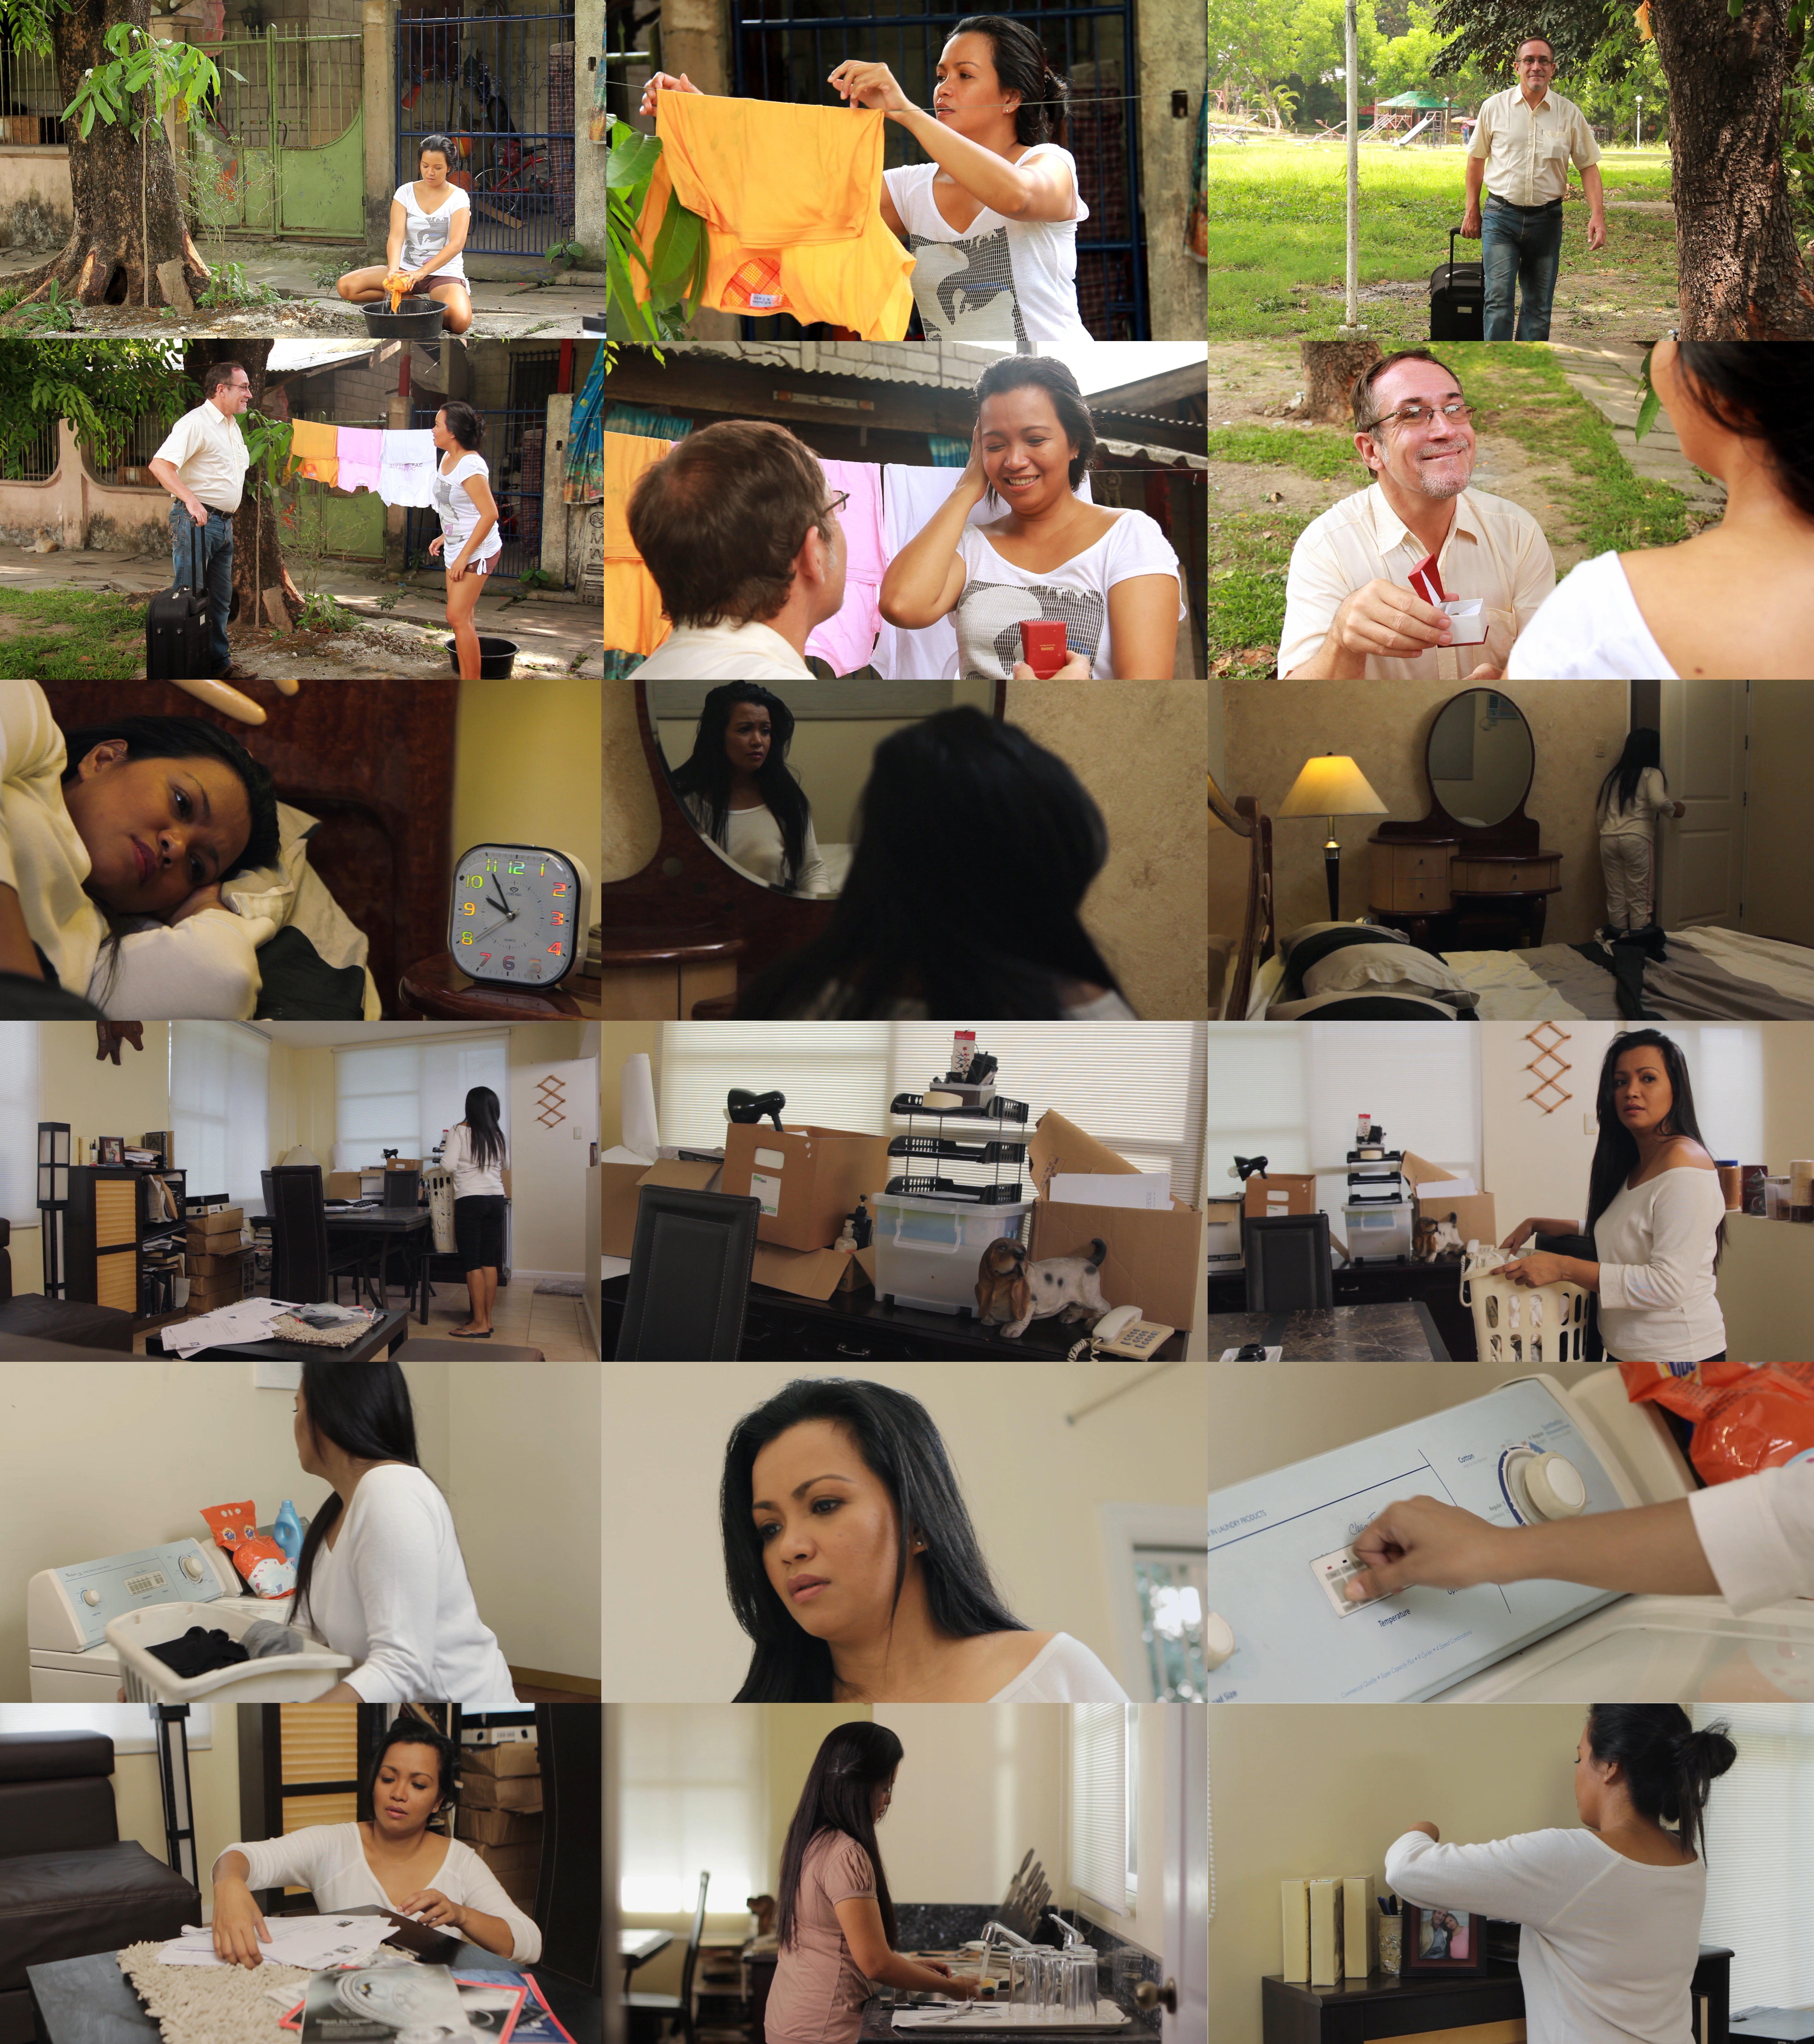

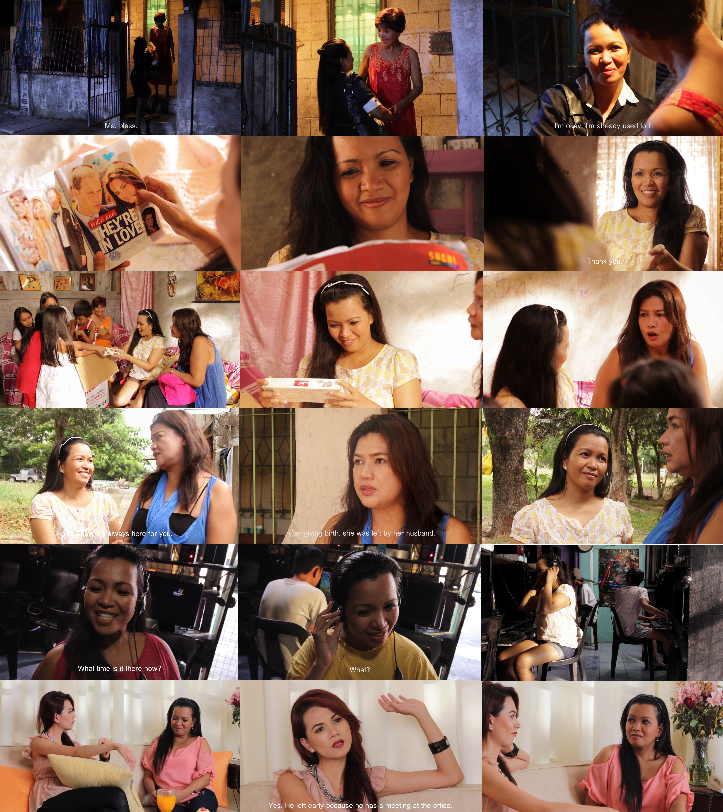

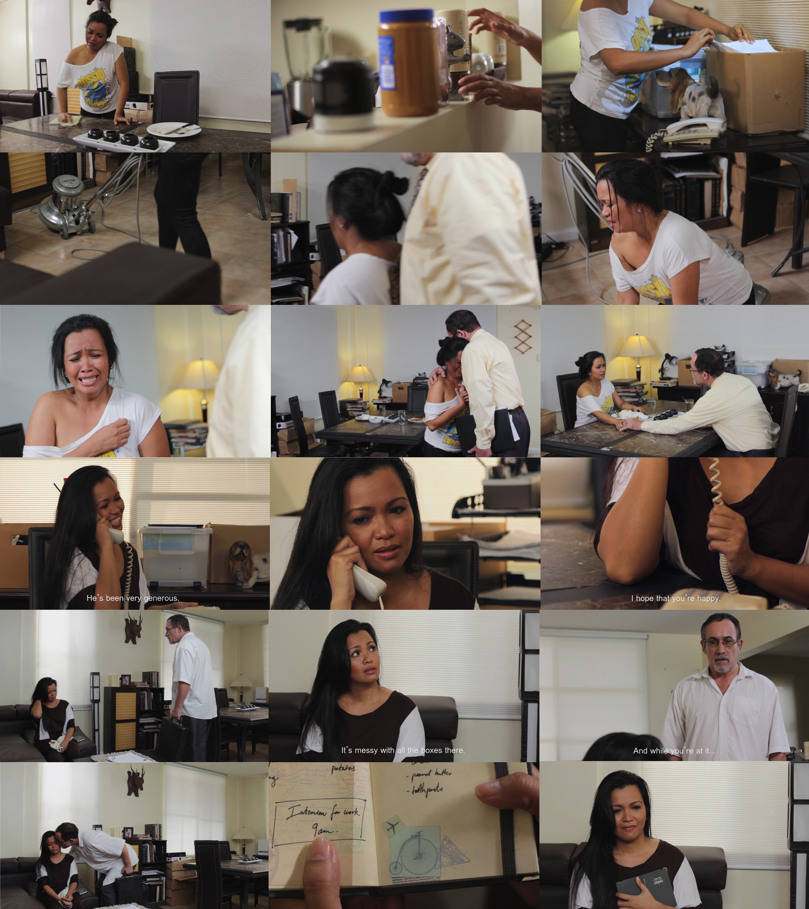

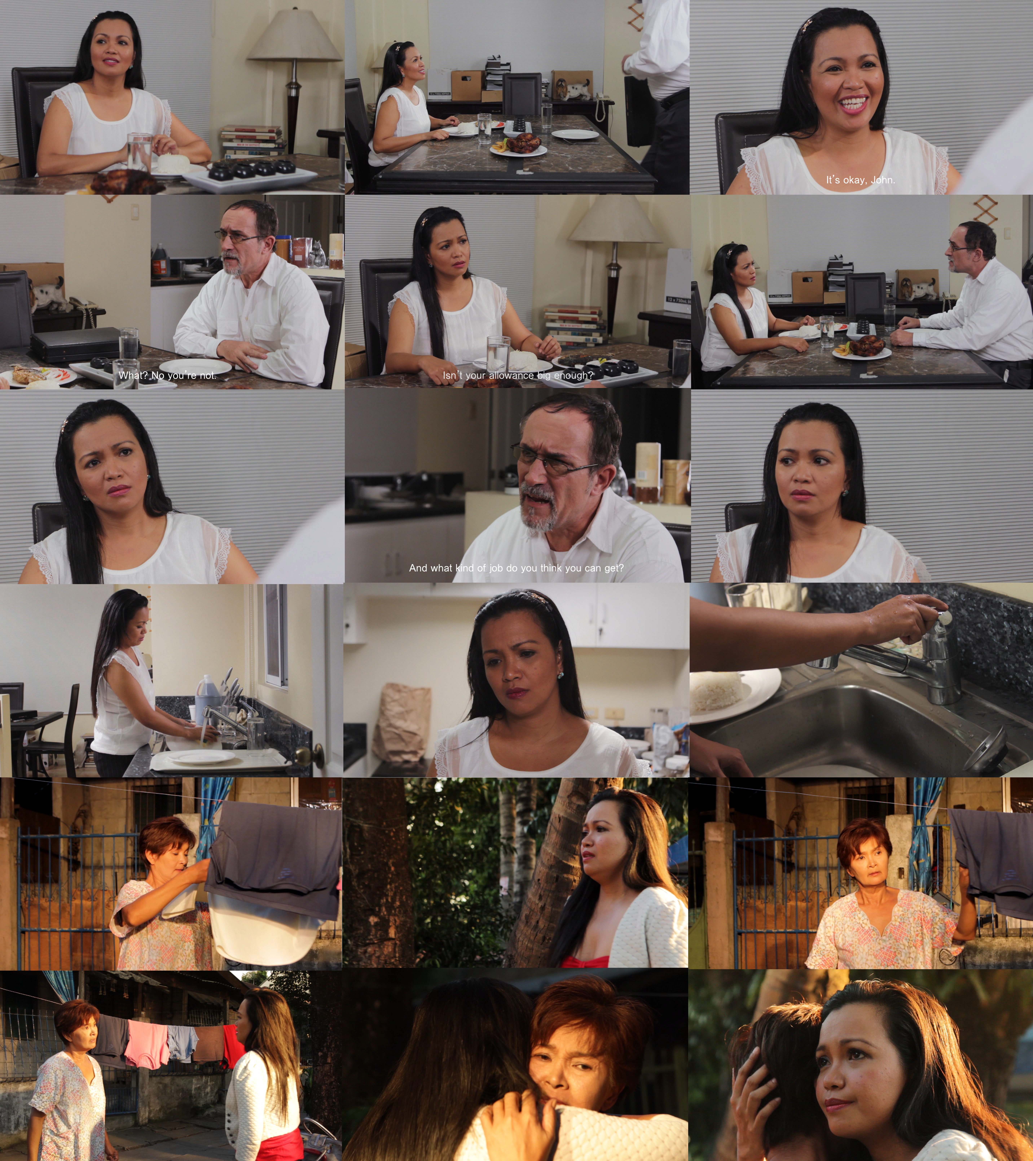

- Faculty Critiques and Recommendations

Most of the panelists considered the material stereotypical and cliché with no fresh insights. They also said the treatment is not well thought-out. Professor Lejano suggested that the material be adapted as comedy. Professor Campos pointed out that the material is very problematic and oppressive both to the American and the Filipina. He pointed out that the filmmaker failed to empower the Filipina. Professor Evidente suggested that the film be shortened because it was too long and the transitions should be made more noticeable. Dr. Santiago also commented that the tension between Helen and John was not played up. Some of the panelists praised the acting of the leads, especially Marife Necesito who played the character of Helen. Also, one panelist commented how the topic of the film is honest and that the realities exposed are very timely.
The filmmaker believes that the film has something new to offer. First and foremost is the fact that the motivation of Helen differs from the usual desire for monetary gains of the mail-order brides. Helen has always obsessed about Caucasian looks. It has been her dream and desire to acquire mestiza-like features by using whitening or bleaching products. However, she has accepted the fact that she is not destined to have this kind of beauty so she decided that she can achieve this vicariously by having children fathered by a foreigner husband. The filmmaker accepts that she fell short in conveying and establishing Helen’s obsession to have beautiful Amerasian children. In retrospect, she should have included more scenes showing Helen obsessing about having children with John. Even in her conversations with Liza, her Filipina friend who has a son by an American, the talk of her wanting children with John and her envy over Liza’s son with Frank should have been played up more. Secondly, the personality of Helen as assertive, independent and determined is in stark contrast with images of Filipina mail-order brides who are submissive and subservient to their foreigner husbands. Helen did enter into the relationship because of the monetary gains. Therefore, she did not want to feel obligated to John and was not willing to be subservient to him simply because he was providing for her and her family. In fact, she was intent on looking for a job in order to be financially independent of him.
The filmmaker admits that she is a neophyte in terms of directing a film, more so a heavy drama. The film should have employed comedic scenes to highlight the tension between Helen and John.
The filmmaker has taken necessary steps in order to balance the image of the Filipina and the American. She has included another American character in the person of Frank, her friend’s husband, who was depicted as having a happy and stable relationship with a Filipina. This aspect was incorporated in the film to depict another American in a good light to counter the image of John. Frank was mentioned in the conversation between Liza and Helen. The relationship of Liza and Frank can be gleaned from the dialogue to show the contrast between Liza and Frank’s relationship with that of Helen and John’s. In the conversation it was stated that though Frank also works long hour like John, he maintains a good relationship with Liza.
Helen’s character intended to show woman empowerment. The filmmaker did not intend the character of Helen to be oppressive to Filipinas. Helen’s decision to return to the Philippines and leave behind her marriage was aimed to reinforce the image of a strong-willed Filipina who refused to kowtow to her husband’s oppression and domination. Helen had the strength of character to defy her husband’s command for her to be a stay-at- home and domesticated wife. She was able to assert her desire to work and to be financially independent of her husband. The indeterminate ending where Helen was shown embracing her mother upon reaching the Philippines give viewers leeway to speculate upon Helen’s future plans. While others may interpret her returning home as a form of weakness, others viewers may view it in a positive light. It may conjure hope for a brighter future in the Philippines for an independent and stronger Helen.
The filmmaker recognizes that the efforts exerted to provide a more fair and balanced image of the characters might not have been enough. She could have shown explicitly other images to counterbalance the negative depiction of John. The filmmaker should have included scenes depicting Helen as having more control and power in the relationship.
The filmmaker takes into consideration the possible re-editing of the film. The only concern is that the film may lose important dialogue if it is presented in a shortened version.
Admittedly, a director’s choice of what story to film, what scenes to portray in the story, the choice of dialogue and the approach to use or the treatment of the story, to a certain extent depends upon the filmmaker’s experiences in life, the depth of her knowledge and understanding of human nature and relationships which may differ according to the filmmaker’s family and educational background. This is expected to change depending upon the filmmaker’s maturity-once she gradually makes the transition from youth to a more mature age.
The filmmaker understands that the comments and suggestions of the panel will help her develop a better film. She plans on focusing more on the development of the story, as well as creating three-dimensional characters. She admits that she has shortcomings in the development of the story as well as the treatment of the narrative. With the help of the constructive criticisms from the panel and the comments of her family and peers, the filmmaker hopes to develop a better eye in assessing what constitutes a good narrative, unbiased representation of characters and the best treatment for that particular story.

BIBLIOGRAPHY

“Mail order Bride legal & Law Definition.” US Legal. n.d. October 2012. <http://definitions.uslegal.com/mail-order-bride>
“Mail-Order Brides: The International Buying and Selling of Women.” Project Social Art.6 December 2011. October 2012. <http://projectsocialart.com/blog/2011/12/06/mail-order-brides-the-international-buying-and-selling-of-women/>
Closer to Home. Dir. Joseph Nobile. Elibon Film Productions, 1995. Film
“Closer to Home.” Everlasting Love. n.d. October 2012.
Say I Do. Dir. Arlene Ami. Red Storm Productions, 2003. Film.
“Say I Do.” Zoom Info. January 2011. October 2012.
<http://www.zoominfo.com/CachedPage/?archive_id=0&page_id=850330506&page_url=//www.redstorm.ca/sayido/prod.htm&page_last_updated=2011-01->
Shattered Glass. Dir. Billy Ray. Baumgarten Merims Productions, 2003. Film
“Shattered Glass.” Wikipedia. 2011. October 2012. <http://en.wikipedia.org/wiki/Shattered_Glass_(film)>
Constable, Nicole. Romance on a Global Stage: Pen Pals, Virtual Ethnography and “Mail Order” Marriages. Berkeley, California: University of California Press, 2003.
Picture Bride. Dir. Kayo Hatta. Miramax Films, 1995. Film
Childs, Peter and Patrick Williams. Introduction to Post-Colonial Theory. Prentice Hall, 1997.
Sicat, Gerardo. “Worker remittances and the Philippine economy.” Per Se. 8 October 2012. October 2012.< www.econ.upd.edu.ph/perse/?p=1628>
Fanon, Frantz. Black Skin White Masks: The Experiences of A Black Man In A White World.France: Editions de Seuil. 1952.
Vakiari. “Social Realism in Film—The European and the American Example.” Project Cinemaas. 2011. October 2012.< http://projectcinemaas.org/social-realism-in-film-the-european-and-the-american-example/>
Crossman, Ashley. “Feminist Theory.” About.com. n.d. October 2012. <http://sociology.about.com/od/Sociological-Theory/a/Feminist-Theory.htm>
Beauvoir, Simone de. The Second Sex. France: n.p; 1949.
Bordo, Susan R. Unbearable Weight. University of California Press, 2003.

APPENDICES
- Thesis Proposal

Janine Paguntalan
2009-12401
Film 199 Research in Film

PINAY DREAM
- INTRODUCTION
OVERVIEW
Watching films has always been an enjoyable pastime for me. A good film effectively communicates with its audience and takes them on an exciting journey. I am attracted to a film because of its use of vibrant colors and dynamic shots. However, the most important aspect for me is how a film conveys its message to the viewer in a way that it leaves them something to think about.
I have always preferred watching certain types of films that relate a story about an underdog who perseveres against all odds and eventually succeeds. I love happy endings. I have always been taught by my parents that if I ever wanted something badly enough, I must strive hard to obtain it. Ideally, diligent effort is rewarded. In the harsh world of reality, such is not always the case. No matter that your goals are pure, no matter that you do everything right, there will never always be an assurance of a fairytale ending.
A lot of the movies we watch in the cinemas give its viewers a distorted idealized sense of reality. They usually present a sure-fire formula for success and happy endings. My film hopes to remove the blinders from the viewers’ eyes. I wish to present the harsh realities that people face in everyday life. In the pursuit of one’s goals, one will encounter a number of people who may positively or negatively affect the course of one’s life. Sometimes, one may be lucky enough to interact with supportive people who will help attain one’s dreams but more often than not, some of the very same people who might pose as friends may in fact be wolves in sheep’s clothing. They might in the beginning appear like knights in shining armor, saviors, but in the end may be unmasked as evil incarnate; such as people motivated by jealousy or selfish vested interests.

My thesis will explore the relationships of people, who though are hindered by their social class strive hard to achieve their goals, and on the other hand people who consider themselves superior and thereby callously take advantage of their fellow human beings.
BACKGROUND
The Philippines is a developing country wherein only a measly 0.3% belong to the upper class (class AB), 8.6% to the middle class (class C) and the unfortunate majority of 91% (class DE), wallow in abject poverty. To compound the problem, our countrymen suffer from poor delivery of basic health services, a high unemployment rate and other social ills. A large number of those who are fortunate enough to earn a college education are either jobless or end up as overqualified underpaid employees.
The limited job market has therefore become highly-competitive especially for those who have not acquired the proper education. In so doing, a numerous number of our underprivileged countrymen have tried to find ways and means to support their families. Some resort to setting up small businesses, take menial jobs, and those skilled enough seek employment abroad as overseas Filipino workers. However, a still higher number resort to criminality or become pawns of criminals involved in drugs and prostitution.
A number of Filipinas, realizing their limited options to improve their status in life, being poorly educated and unskilled, though unwilling to become victims of white slavery opt to better their lives through other means. It has therefore become the dream of these women to eventually meet and marry men from other shores who would save them from their life of poverty in the Philippines. This has given the rise to the phenomenon of the Filipina mail-order bride.
These women believe in the sanctity of marriage and that becoming a mail-order bride is not degrading. Finding a foreign husband has therefore become a dignified option for them. They justify their actions as a means not only to uplift themselves solely but their families as well. They envision themselves as their family’s savior.
The mail-order brides’ actions can further be justified by the fact that the Filipino society has a very strong sense of family. We have a close-knit family system. It has been imbedded into our consciousness that we have the responsibility to take care of our parents and our siblings. No sacrifice is too great to undertake in order to express our love for our family members. This accounts for the fact that our countrymen are willing to work and live abroad, away from their family, just to meet the needs of their family members and provide them with a better future.
I for one belong to a closely-knit family. I strongly believe that my family should always come first. Helping my family in times of need is second nature to me. Though I belong to the upper middle class, and not in any way financially-disadvantaged I know deep in my heart that if and when the time comes that my help will be needed, I will not hesitate to fulfill my responsibilities and obligations to my family. Therefore, in a way, I could relate to Helen, the character in my story. Helen has strong family values. She willingly and unselfishly helps support her siblings’ education and helps defray household expenses. A hard worker, on her shoulders now lie the sole responsibility of supporting her family and her ailing father who suffered from a debilitating stroke. It is therefore to her credit that she is willing to sacrifice everything for her family even to the extent of marrying a foreigner she barely knows.
Even before, there have been many Filipina mail-order brides. In a study covering the years 1989 to 1994, it has been reported that majority of mail-order brides come from the Philippines. Statistics from the Commission on Filipino Overseas states that mail-order brides constitute 10% of the marriages between Filipinas and foreign nationals. Americans account for 44% of foreign men who marry Filipinas. The study revealed that most of the women who married American husbands were poorly educated, low-income earners and hailed from areas with poor employment opportunities. When queried as to the reason why they married Americans, there was no mention of such conditions. Instead, they claimed that they were attracted to their husbands and they believe that Americans are kind and faithful as opposed to Filipino males who were cruel and unfaithful.
However, contrary to their belief, numerous cases of abuse of Filipino mail-order brides have surfaced in the media. There are unfortunate cases where Filipinas are trapped in unhappy marriages where they are at times bullied, verbally or sexually abused by their foreigner-husbands. One hears or read of stories of Filipinas being offered by her foreigner husband as sexual playmates to his friends or murdered for insurance money.
In response to this, the Congress of the Philippines enacted Republic Act 6955 or the Anti-Mail-Order Bride Law in 1990. RA 6955 states that it is unlawful for any person, association, club, or entity to establish business for matching Filipino women to foreign nationals, solicit or introduce any Filipino to become a member of such association. Anyone found guilty of such will be subject to six years imprisonment and a fine of Php 8,000-20,000. Foreigners found guilty of this crime will also be deported and barred from the Philippines. Be that as it may, many Filipinas still aspire to marry foreign husbands they hardly know. Some overlook the dangers that mail-order brides may encounter.
RATIONALE
The main idea for this thesis concept came from eavesdropping on the day to day conversations of our house helps regarding their hopes for the future. Even as a kid, I have been privy to the secret longings of my own nanny to meet and eventually marry a foreigner. I would frequently hear her and our other helpers talk about their love lives, their boyfriends, and their longing to meet foreigners. They speak with envy of their friends who as Japayukis met and married rich Japanese and of overseas contract worker relatives who ended up marrying foreigners. Time and again they have expressed their dreams and their desire of someday meeting and marrying a foreigner who will rescue them from a life of poverty. My nanny shares this hope with the saleslady in the department store, the grocery girl behind the counter, and many more Filipinas dreaming of a better life that they believe only a foreigner husband could provide.
This Pinay dream may be triggered by envy from what they see around them—the sudden change in fortune of an informal settler able to acquire a beautiful house after working abroad, stories in the media of successful Filipinas who married foreigners and the respect accorded to the likes of other Helens who decently married a foreigner instead of becoming a mistress or a prostitute. Thus, through Helen I aim to discuss a phenomenon that is commonly happening today—the Filipina mail-order bride.
Mail-order brides are “women who list themselves in catalogs (online or otherwise) and is chosen by men for marriage. For the purposes of my paper, mail-order bride will be loosely defined as women who seek marriage with foreign men through internet-based meeting sites. These women generally come from impoverished areas in Asia like the Philippines.
The preponderance of the mail-order bride phenomenon is viewed by some as a form of greed and exploitation. Critics look at mail-order brides as ambitious social climbers and money greedy harlots who would settle for a marriage for convenience, a loveless union, in exchange for a better life or money. This film hopes to paint a different picture in the person of Helen. I hope to present Helen as the sacrificial lamb who hoped to alleviate her family from a life of poverty. Poorly educated and with no skills to speak of, she tried to cope by the only decent and dignified means she could think of. While initially, Filipino mail-order brides marry for financial reasons, I would wish to highlight an estimable and deeply-ingrained Filipina virtue which entails commitment in marriage. Thus, despite an initially loveless marriage, a Filipina successfully transforms it into a love-filled relationship because of this trait. Due to the Filipina traits of loyalty and devotion to husband and family, love would automatically and naturally follow. So in the case of Helen, while she entered the marriage for financial considerations, there was an effort on her part to make love grow between her and John. In a way, she epitomizes the hundreds and even thousands of Filipinas who are willing not only to sacrifice themselves to help their impoverished families but who strive to make her marriage with her foreigner spouse work, as well.
I wish to present a deeper understanding of the Filipina’s sense of loyalty not only to the families they leave behind in the Philippines but likewise to the men they marry. This strong sense of loyalty enables them to get past cultural differences and would account for a number of happy marriages some of these mail-order brides eventually establish. Helen’s character went to great lengths to better herself to be worthy of John and tried her best to be a good housewife. Had the circumstances been different with John, Helen’s story might have ended happily.
As in Helen’s case, I want to point out that unfortunately, some Filipinas are trapped in unhappy marriages where they are bullied verbally, physically, emotionally or sexually abused by their foreigner husbands. Helen’s innocence and optimistic outlook in life made her an easy prey for John. Women like her who are in dire need are the ones who are desperate enough to throw caution to the wind. I want to remove the blinders from the eyes of the many Helens who “refuse” to see things as they are.
My thesis tackles the segment of the Filipina population who resorts to unorthodox means in order to rise above poverty and the exploitation they experience, represented by the protagonist Helen. Having a deep sense of responsibility and love for her family, Helen sacrificed a lot in order to a better life for her and her family. She set aside her own happiness for the happiness of her family. Even if she would be away from her family for a long time, she pushed through with her decision to marry John thinking that by marrying him, everything will fall into place. The decision to marry a foreigner was also influenced by the innocent envy that she and her mother experienced over the fact that a relative became rich by marrying a foreigner. In a way, it can be said that Helen exploited John for financial gain.
To sum it up, this film portrays the longings and aspirations of a present modern Filipina. It discusses the unconventional and possibly dangerous actions they take in order to lead a better life and the consequences they may face. It also presents that not everyone that they will encounter may help them. Some might even take advantage of them.
- REVIEW OF RELATED WORKS AND LITERATURE
- Closer to Home by Joseph Nobile (Elibon Film Productions, 1995)
This film tells the story of Dalisay, an underprivileged seventeen year old Filipina who lives in the province, and her journey to New York City to marry Dean, an ex-merchant marine coming from a lower-middle class family. She sees Dean as her passage to the land of milk and honey. She believes that marrying Dean and living in the United States will help her buy a cure for her dying sister and eventually give a better future for her debt-ridden Filipino family.
Dalisay’s actions in marrying Dean stem from her desire to obtain financial support needed for her sister’s heart surgery and to ultimately help give a better life to her family. This aspect of the film will help the filmmaker establish a sympathetic view of Helen’s actions. Helen’s father who just suffered from a stroke is bedridden and her mother earns only a little. It is up to Helen to support her four siblings’ education, her father’s medical expenses and house bills.
- Say I Do by Arlene Ami (red storm productions, 2003)
This documentary film archives three stories of mail-order brides from the Philippines currently living in Canada. These three women married men they did not know to escape poverty and to be able to help support their families. When they arrived in Canada, they resided in isolated areas of the country. One woman discovered the violent side of her husband. These women did not know anybody in their area aside from their husbands. They said that their husbands were “men who searched for women with traditional family values, and were unsuccessful with Canadian women whom they felt had many freedoms and were spoiled.”
The description the mail-order brides gave their husbands will be used in the filmmaker’s thesis in establishing John’s thinking. He is under the impression that Asian women have this kind of quality and that they are passive women unlike western women. John discerns that he has the power over his wife especially because his wife is dependent on him.
Also, in this story, it was established that the women were isolated—they did not know anybody else except their husbands. This aspect can further help establish the setting where John killed Helen. Helen did not know anyone else besides John in their area. She did not have any support group whatsoever that could have helped her settle down and adapt to her new environment. Her death would not have caused much stir in their neighborhood and there would be no further investigation regarding this matter.
- Shattered Glass by Billy Ray (Lion Gate Films, 2003)
This film talks about the story of Stephen Glass, a writer at the in-flight magazine of the Air Force One called The New Republic. Stephen Glass is first seen giving a talk to a bunch of students in a classroom in his old school. There, he tells the students how he got a spot at the magazine. The film shows a flashback of Stephen Glass as a writer. The flashback showed his experiences as a writer and the journalistic fraud that he has committed. The film bounces back and forth from the present time to the flashbacks. The classroom scene is shown again. Stephen is standing in front of the empty room. The story ends with Stephen being fired in his job that resulted from his 27 articles that were fabricated in whole or in part.
The form of the story will be adapted to the filmmaker’s thesis. The film will show three moments in time—the present, the flashbacks and the revelation. Just like the treatment of Stephen’s supposed speech with the students, the film will show the funeral preparations masked as a wedding. Only at the end will it be revealed that Helen’s family was actually preparing for the memorial service of their daughter.
- Romance on a Global Stage: Pen Pals, Virtual Ethnography and “Mail Order” Marriages by Nicole Constable (university of California press 1 edition September 18, 2003 293pp)
In this book, Constable discusses the image of women who are labeled as mail-order brides and states that they are less fairly represented, less well understood and at a disadvantage in showing their perspectives as compared to the men who marry them.
Mail-order bride catalogs Oriental women as the opposite of their liberated western feminists Asian women are portrayed as one who dreams of meeting and marrying someone rich and powerful, who will free her from poverty. While the American man is portrayed as one who dreams of meeting and marrying a passive, obedient, non-threatening, virginal woman who will devote her entire life serving him and making no demands. Asia is also depicted as a site of patriarchal fantasy for men who feel that male pre-eminence in the family are being undermined.
Out of the 40 mail-order brides Constable interviewed each from China and the Philippines, findings stated that most of the women from the Philippines used internet cafes to communicate with possible foreign husbands and that they came from rural areas. Several of the Filipinas belonged to a lower socio-economic class compared to the Chinese women, i.e., nursery-school teachers, shop clerks, domestic helpers, factory workers and waitresses.
In her interviews, she found out that women made informed decisions and that they were very much aware of the dangers that they might face. It was also found that mail-order brides refuse to acknowledge that they are “selling” themselves. Instead, they believe that they assume active roles in the courtship process of mail-order marriages.
Constable asserts that not all mail-order marriages have a destructive relationship and not all foreign husbands resort to physical abuse. However, she acknowledges that inequalities between partners in this marital transaction may in fact lead to exploitation since the male spouse may feel that he is superior to his mail-order bride and that he has “bought” her. Constable quotes Roland Tolentino in the representation of mail-order brides as the foreign man’s colonialist fantasy or racial conquest and rescue. Constable points out further that the women should be correctly portrayed to show how they assert dignity and express strength instead of a passive sex object and a submissive wife since the current inaccurate representation, risks catching the attention of abusive men.
The character of Helen will establish her motivations and aspirations in becoming a mail-order bride i.e., to provide a good life for her family. It will be shown that her socio-economic and educational background plays an important role in her decision to marry a foreigner. Her choice is also influenced by a cousin who cultivated a successful and loving relationship with her foreign husband.
Her actions will present a character that assumes an active role in the courtship and that she is informed of the repercussions of such action. Helen’s character will highlight deeply-ingrained Filipina virtues—commitment to marriage, loyalty and devotion to husband and family, the sincere desire to make a marriage work and make it last and the Filipina ideal of a love and marriage which will last forever. Thus, while marriage may be initially viewed as a marriage for convenience or based on financial considerations, Helen’s character will show that through this natural Filipina virtue and sense of commitment, she will muster the effort to make love grow out of the seemingly “mercenary” relationship.
To stray away from creating an image of Americans as abusive husbands to mail-order marriages, John will assume a psychological disorder that will support his actions. John longs for a lasting love but could not cope with building a successful relationship because of unresolved issues from his childhood. As a child, John was abandoned by his mother and was left in the care of his strict and disciplinarian father. The possibility of abuse from his father, though not stated, is a possibility. The psychological trauma left by his mother’s abandonment of him as a child will give him “anxiety attacks” every time someone he loves threatens to leave him. The threat of abandonment will trigger an irrational reaction on his part and will awaken his killer instinct, hence, the murder of Helen.

- Picture Bride by Kayo Hatta (1995, Miramax films)
This film talks about the story of Riyo, a 16 year-old city girl from Japan. When her father died, she was forced by her aunt to become a picture bride. She then was arranged to be married to Matsuji, a farmer in Hawaii. The two of them met and she finds out that he was REALLY older than the picture. Riyo and Matsuji are married and they travel to their home in the sugar plantation. Riyo fights off Matsuji’s attempts at intimacy. She did not want to be married to Matsuji so she decided to save up money to move back to Japan. Unfamiliar with farm work, she is harassed and ridiculed by the field supervisor. She starts working harder and taking on extra work to be able to save up from the small wages that is given to them. Riyo develops a friendship with Kana, a co-farmer. Kana advises Matsuji to start being romantic to Riyo to win her heart. The field supervisor drives the workers to do more work to meet the crop in time. The farmers who have children are constantly worried about their children who are left while they are working. Kana asks the field supervisor to have their children closer to the workers when they transfer to another field. The field supervisor threatens to whip the workers when Kana tries to stand up to him. When the cane fields are set on fire, Kana realizes that her kid is nowhere to be found. She tries to find him in the middle of the burning field and both are lost. The workers talk about waging a strike. Riyo assumes leadership on the field, replacing Kana.
Riyo and Helen were both married off to men they were not familiar with. Both of them migrated to foreign countries in hope of a brighter future. Riyo’s actions are the opposite of Helen’s. While similarly situated, Riyo was in command of the situation and rose above the odds, unlike Helen who till the end remained an underdog.
- FRAMEWORK
Post-colonial
The aspect of the post-colonial theory that is relevant to this film is the contention that there is continuation of colonialism by means of economic, social, cultural and linguistic influences on the colonized long after the mother country has left. The Philippines was colonized by the Americans decades ago but their influence is still strongly evident in our culture. The film represents United States of American in John while Helen represents the Philippines. The Philippines is one of the few countries in Asia where a large number of the population speak English. We have in fact embraced English as our second language. Our culture has been enriched by anything and everything American through our constant exposure to a barrage of American music, television shows, movies, and brands to name but a few. The proliferation of imported American products in the Philippines is a testament to this. Likewise, our economy is strongly linked to the American dollar. It therefore comes as no surprise that Filipinos think highly of America and of Americans. America is believed to be a land where dreams come true. Many Filipinos living in harsh conditions look to America as a land of promise, a place for a better life. Most of our countrymen aspire to work abroad where they will earn more. Others want to marry Americans who they consider financially stable. Helen dreams of going to America. Having heard and seen many wonderful things about America, she believes that John holds the key to a better life.
This theory also deals with how people are swayed by propaganda and are virtually brainwashed by their colonizers. They are bombarded by half-truths that promote the colonizers’ self-serving interests. The story points out that Helen’s dependence on John was the reason she allowed him to physically and emotionally abuse her. Helen was willing to endure everything because John supported her and her family financially. On the other hand the financial gain of John for Helen’s death represents the fact that our dependence on America may not just be one-sided—that we are not the only ones who benefit from the relationship. America also benefits from the Philippines. This is contrary to the belief that is perpetuated by America that we are heavily indebted to them and that they do not in any way benefit from us.

Social Realism
Social realist films depict how people deal with issues in everyday life. It tackles relevant issues alive in modern society with themes which explore social, racial and economic realities. It opens the audience’s eyes to the struggles of the disadvantaged segment of our society. This film will be grounded on social realism as it touches on the mail-order bride phenomenon that is not commonly discussed in the Philippines. The film will touch on the issue from a specific social perspective, through the lens of the Filipina mail-order bride.
The social realism style is known for its naturalistic approach, reflecting the simple emotions of the characters. This style will be used in the film as it highlights the whirlwind of emotions Helen is set to experience in the story. The social realism style will be adapted in the film as it captures Helen’s story in a natural and realistic way. Social realism will help develop the narrative as it aims to show how Helen is determined to embark on a courageous and dignified solution to rise above a life of poverty.
The location that a social realist film is said to be shot in is usually specific on the grounds that the character is constructed and examined in its interrelations within the society that she is placed. In Helen’s case, her personal experiences as a Filipina in a foreign country will be shown to provide a glimpse of how it is to live in a foreign country and to provide insights to Filipinas in the future who share Helen’s dream.

- TREATMENT
The film will have three planes—past, present and a revelation. The present timeframe will delve on the funeral of Helen. It will be shot in a manner that will appear as though preparations are underway for Helen’s wedding. The past will be inserted into the present with cut-to-cuts.
The present story will be the funeral of Helen. It will be shot in a manner that it will look like the preparations of Helen’s wedding. The past story will then be inserted into the present story with cut-to-cuts. In the revelation, Helen will be murdered by John and John will receive the insurance money. Finally it will be revealed that the supposed wedding preparations are actually preparations for Helen’s funeral.

- SYNOPSIS
Helen is a 25 year-old saleslady from Manila. She is the eldest child of Pidel, a tricycle driver and Sita, a laundrywoman. She has four younger siblings who are still studying. Belonging to a very poor family, she helps augment their finances by working as a saleslady in a department store. Her father suffers a massive stroke leaving Helen the burden of solely supporting her family. Due to extreme financial difficulties Helen seeks the help of John, her 58 year-old American fiancé whom she met online.
Helen constantly talks to her co-workers about John and his impending arrival in the Philippines for their wedding. She narrates how she tries her best to learn English by watching English television shows and movies. Her friends express their envy in her good fortune of meeting John. They share their hopes and dreams of someday marrying a foreigner also. They end up talking about relatives and acquaintances whose financial situations improved after marrying foreigners.
Shortly after marrying John in the Philippines, Helen joins him in the United States. Helen lived with John in an isolated rural community. A virtual prisoner, she is only allowed to leave the house in John’s company. She experiences verbal and physical abuse at the hands of her husband. She occasionally attempts to fight back. However, she soon realizes that she is financially dependent on John so she tries to endure her situation. The few times that John is nice to her are when he asserts his husbandly rights. Helen occasionally sends money and balikbayan boxes to her family. She keeps the abuse she suffers in the hands of John from her family. She tells her family she is happy and is enjoying her stay in the US. The few times she skypes with her family on the internet, she covers up the bruises she has sustained.
Six months later, after a big fight with an unjustifiably jealous John, Helen threatens to leave him. John begs her to stay and not abandon him the same way his mother did to him and to his father. From then on, he promised to be a better husband. .To patch things up between them John promised to take her on a vacation. In high spirits, Helen talks to her family at home and informs them that she won’t be able to communicate with them in the next few weeks since she and John are going on an extended vacation.
Helen and John are in a boat on a lake—happy and in a celebratory mood. John pushes a surprised Helen off the boat into the water. A few days later, Helen’s parents receive a letter from John informing them that Helen accidentally drowned during a boating trip. They are deeply saddened and devastated. Helen’s remains are flown back to her family who are unaware of the real circumstances behind her death. While in the United States, John receives a call from the insurance company informing him that his wife’s $100,000 death insurance check is ready for pick-up.

- Script
SEQ 1. INT. KWARTONG KAINAN, BAHAY NI HELEN. UMAGA
Nakaupo sa dining room si SITA, 60 taong gulang, nanay ni Helen. Payat ito, maputi ang buhok, suot-suot ang daster na kupas. Konkreto ang sahig at dingding. Walang pintura ang dingding pero pilit pinasisigla ang kwarto ng kurtinang matingkad ang pagkadilaw. Nakalatag sa dining table ang mga mga litrato ni Helen ng bata pa ito hanggang magdalaga.
SITA
(tumitingin sa kanyang kanan)
Helen, naaalala mo pa ba, yung litratong kinuha sa ‘yo? Birthday mo ito nung limang taon ka. Ang ganda ganda mo nga dito eh kaso nagtatakbo ka sa putikan kaya tingnan mo puro galos at putik ang tuhod mo. Eto naman nung nag-graduate ka ng highschool. Sinong mag-aakala na ang suot mong puting damit na ito ay hiniram lang natin kay Aling Chabeng. Bagay na bagay sa ‘yo anak. Maliit ka pa nun, alam kong ikaw na ang magbibigay ng ligaya sa amin ng tatay mo. Sino ba namang mag-aakala na eto kami ngayon abala, naghahanda para sa’yo.

SITA
(mapapatingin kay RONNIE, 15 taong gulang)
Ay, Ronnie, ayus-ayusin mo yung alambre nakausli sa gilid ng kurtina. Nakakahiya naman maraming darating na bisita.

SEQ 2. EXT. KALYE MALAPIT SA BAHAY NI HELEN. DAY
Makikita si HELEN, 25 taong gulang, suot ang kanyang uniform na binabagtas ang kalye papunta sa kanyang pinagtatrabahuhang department store. Morena at balingkitnitan ang kanyang pangangatawan. Magulo ang eskinita at puno ng mga batang madudusing at maingay na naglalaro. Maliliit ang mga bahay at dikit-dikit. Hinahabol siya ni BENG, 9 years old, ang kanyang nakakabatang kapatid.
BENG
(humihingal at umiiyak)
Ate, si papa! Biglang nanigas tapos bumagsak sa sahig!
HELEN
(gulat)
Ano?!
Dali-daling kumaripas ng takbo si Helen at si Beng pabalik ng bahay.

SEQ 3. INT. KAINAN MALAPIT SA DEPARTMENT STORE. HAPON
Madami ang kumakain sa fast food area. Maingay ang mga kalansing ng kutsara’t tinidor pati na ang mga usapan ng mga kumakain. Habang kumakain, kinakausap ni Helen ang kanyang katrabahong si JOVIE, 26 taong gulang.
HELEN
Nako friend, talagang ang hirap ng buhay ngayon. Di ko na alam kung ano gagawin ko. Nagpaalam na nga ako kay sir na magdodouble shift na lang ako eh. Sabi ng doktor nastroke daw si tatay. Paralisado na yung katawan, di makagalaw. Kaya ako ngayon, magdodoble ng trabaho. Di talaga kakayanin ng sweldo ni nanay sa paglalabada. Hay nako di ko na alam kung saan ako hahagilap ng pera para pangtustos kay tatay.
JOVIE
Baka namang pwede kang humingi ng tulong kay papa John?
HELEN
Nakakahiya naman yata na manghihingi pa ako ng tulong eh alam ko namang malaki rin ang gagastusin niya sa nalalapit naming kasal. Madadagdag pa sa iisipin niya yung problema ng pamilya ko.
JOVIE
Hindi naman siguro friend. Diba kaya nga tayo naghahanap ng foreigner eh, para sa mga pagkakataon na ngangailangan tayo, eh meron tayong malalapitan. Kaya nga ako ang hinahanap ko yung hari ng Brunei eh. Joke. Pwede na kahit na Australiano. Helen, wala nang hiya-hiya. Bakit, magiging asawa mo rin naman yan ah? Anong masama sa panghingi ng pera? Sa panahon ngayon, dapat, praktikal ka na.
HELEN
Sabagay. May apat na kapatid pa akong pinapaaral. Hay nako friend. Sana hindi na lang tayo pinanganak na mahirap para hindi natin pinoproblema yang mga yan.
JOVIE
Pero pansin ko ngayon ah sosyal ka na. Pa-mcdo mcdo ka na ngayon ah.
HELEN
(tumatawa)
Hindi naman pero syempre kailangan ko na masanay. Lagi nga ako nanunuod ng mga palabas sa telebisyon na Ingles. Kailangan ko rin namang matutong mag-ingles. Gamit na gamit na nga yung ingles-tagalog dictionary ko!

SEQ 4. INT. KWARTO, BAHAY NI HELEN. HAPON
Sinusuklay ni Sita ang kanyang putting buhok. Nagpupulbo at naglilipstick ito. Si Beng at mga kapatid niyang si RAQUEL, 17 taong gulang, at si Ronnie, ay bihis na bihis. Nakaputing damit si Raquel at nakaputing polo at itim na pantaloon si Ronnie. Lumabas si LOTLOT, 8 taong gulang, sa banyo.
SITA
(titingin kay Lotlot)
Anak mag-ayos ka naman ngayon. Importanteng araw ito sa ate mo eh, ha?
Papabalik na si Lotlot sa banyo ng may ipinaalala ang kanyang nanay.
SITA
Lot, nagawa mo bang inutos ko sa’yo anak? Ang mga monoblock chairs sa labas, nakabalot na ng puting tela? Nadamitan na?
LOTLOT
Opo ‘nay. Tinulungan po ako ni ate Beng.

SEQ 5. INT. INTERNET CAFÉ. UMAGA
Puno at siksikan ang computer shop. Sampung computers ang dikit-dikit sa isang maliit na kwarto. Bata at matatanda ay tutok na tutok sa paglalaro ng video games at pag-iinternet. Si Helen at si JOHN, 55 taong gulang na Amerikano, ay nag-chachat at nagpapakita ng kanilang video stream.
JOHN
I understand what you’re going through. Don’t worry Helen, I will help you. I also was the one who took care of my dad who was ill for a long time. Even though he was very strict, he was the only one I had.
HELEN
Wer s ur mother?
JOHN
I was only a little boy when my mom turned her back on us and abandoned us.
HELEN
Ah ok. Sori 2 hear dat. Thank u very much 4 ur help. Ur so kind. Im so excited 2 c u coming here in my country. I already prepared all documents needed 4 our wedding.

SEQ 6. INT. SALA, BAHAY NI HELEN. GABI
Helen and Sita are in the dining area. They are washing the dishes.
SITA
Anak, napadala na bi John yung pera? Kasi marami pa tayong babayaran sa ospital.
HELEN
Opo ma. Bibilhin ko po yung gamot ni papa bukas pagkatapos ng trabaho ko.
SITA
Kelan dating niya? Malapit na kasal niyo. Excited na ako anak.
HELEN
Malapit na po ma, sa katapusan na. Ma, mag-iingat kayo dito nila papa pag umalis na ako ha. Parati tayong mag-usap. Marami namang internet café dyan, magpaturo ka na lang pano mag-chat.
SITA
Buti na lang talaga nakilala mo si John. Tingnan mo yan kung di ko pa sinabi sayo na maghanap ka ng foreigner, edi wala tayong mahihingan ng tulong.Nakita mo naman yung pinsan mo diba! Nakahanap ng Hapon, tapos ngayon may dalawa ng anak, nandun pa tito tita mo. Pa-relaks relaks na lang dun.

SEQ 7. INT. SALA, BAHAY NI HELEN. UMAGA
Si Sita ay lumabas na ng kwarto at pumunta sa kanilang sala.
SITA
Beng, Beng, ‘nak. Yung mga bulaklak dalhin niyo na dito ni Raquel. Kunin niyo sa banyo yung nakababad sa lata. Ronnie, pumutol ka ng mga uhay ng saging dun sa labas.
RONNIE
‘Nay, para saan po yun?

SITA
Ay, huwag ka nga makulit. Itusok mo yung bulaklak doon para hindi madaling malanta. Bilis na ‘nak. Pakigawa na.
Aayusin na ni Beng, Raquel at Ronnie ang mga bulaklak sa uhay ng saging.
SEQ 8. INT. KWARTO, BAHAY NI HELEN. UMAGA
Pupuntahan ni Helen ang kanyang tatay para magpaalam sa kanyang pag-alis papuntang America.
HELEN
Pa, aalis na po ako. Mamimiss po kita. Wag kang mag-aalala mag-iingat ako dun. Di ko kayo kakalimutan. Pramis. Magpapadala ako sa inyo sa abot ng makakaya ko. Magpagaling ka kaagad, pa. Para pag dumating na ako, mamamasyal tayo kasama ng asawa ko.
Lalabas si Helen ng kwarto

SEQ 9. INT. BAHAY NI HELEN. UMAGA
Binubuhat ni John ang kanilang mga maleta at ilalagay sa likod ng taxi. Ang pamilya ni Helen ay nakahilera malapit sa pinutan. Yayakapin ni Helen ang bawat kapatid.

SITA
O anak, mag-ingat ka parati doon ah. Kung nalulungkot ka man, nandyan ang internet. I-chat mo lang kami o kaya tumawag ka. Wag kang mag-alala sa amin lalo na sa tatay mo. Hindi namin siya pababayaan. Isipin mo parati na maging mabuting asawa kay John.
HELEN
Oo naman ‘nay.
SITA
(whispering)
Anak, wag kang makakalimot na tumulong sa’min. Aasahan ko yan ‘nak ah?

SEQ 11. INT. KUSINA, BAHAY NI HELEN. UMAGA
Pinuntahan ni Sita ang kanilang kusina. Samu’t saring mga pagkain ang nakahanda—may pansit, may hotdog, at iba pa. Ang kanilang kamag-anak na si BUDJI, 20 taong gulang, ay nagpapahid ng margarine sa pandesal.
SITA
Budji, salamat sa pagtulong ah. May kailangan ka pa ba?
BUDJI
Ay tatakpan na lang po ito para di langawin mamaya pag kakain na po.
SITA
Ah osige sige. Kung kailangan mo ng tulong, magtawag ka lang ah?

SEQ 12. INT. SALA, BAHAY NI JOHN. UMAGA
Si John ay nakaupo, nakatitig sa pintuan. Papasok ng bahay si Helen.
JOHN
Where did you go?
HELEN
I shopped for grocery. The refrigerator is almost empty.
JOHN
(sisigaw)
Who were you with? Did you go out with your boyfriend? Are you playing around?!
Hahawakan ni John ang braso ni Helen at kakalugin niya ito.
JOHN
What now? You’re going to leave me? You want to go and be with your boyfriend?
Sasampalin ni Helen si John.Biglang iiyak si John.
JOHN
You are going to leave me, Helen. Everyone leaves.
Magbubuntong-hininga si Helen at yayakapin si John.
HELEN
No, John.

SEQ 13. INT. SALA, BAHAY NI JOHN. GABI
Kukunin niya ang kanyang cellphone. Titingnan ni Helen kung tulog na si John. Pagtapos ay tatakpan niya ang mga pasa sa kanyang mukha. Bubuksan niya ang kanyang laptop.

HELEN
Nay! Kumusta? Nakuha mo ba padala ko? Okay naman kayo dyan? May problema ba? Si papa, yung mga kapatid ko?
SITA
Oo anak, mabuti naman kami dito. Syempre ba naman alagang alaga kami ng anak ko at ng manugang kong napakagwapo. Yung mga kapatid mo, ayun, si Beng at si Raquel, maayos naman. Tinutulungan ako sa labada at sa pag-aalaga sa tatay mo. Si Ronnie naman tumaas ang mga grado sa iskul. Si Lotlot naman grabe sa kulit.
HELEN
Miss ko na kayo nay. Uwi kaya ako dyan?
SITA
Ay nako! Tumigil ka nga dyan anak. Edi pag umuwi ka dito, baka di mo na kami masuportahan. Yung tatay mo, medyo nakakatayo-tayo na nga eh pero may alalay lang talaga. Anak, pasalamat ka nga kay John oh. Ang dami dami na niyang binibigay sa’tin. Baka isang araw wala na kayong makain ah.
Ngingiti si Helen ngunit bigla rin itong sisimangot.

SEQ 14. INT. KWARTO NI JOHN, BAHAY NI JOHN. GABI
Nasa sulok ng kwarto si Helen. Si John ay galit na galit at nagsisisigaw.
JOHN
(sisigaw)
Who were you talking to a while ago?!

HELEN
The mailman. He delivered something. Why, what is wrong?
JOHN
Didn’t I tell you not to talk to anyone? What did you do? Were you flirting with him? Are you going to have a date or what?
Hahawakan ng mahigpit ni John ang braso ni Helen. Kukunot ang noo ni Helen sa sakit.
HELEN
You’re hurting me, John. Stop it!
Hahawakan ni John sa panga si Helen.
JOHN
You stop flirting with other men! You understand me?

SEQ 15. INT. SALA, BAHAY NI JOHN. GABI
Lalabas si John sa kanilang kwarto. Makikita sa mukha niya na may kalmot ito. Iinom siya ng pill.

SEQ 16. INT. KWARTO NI JOHN, BAHAY NI JOHN. GABI
Umiiyak at gulung-gulo si Helen. Hinalungkat niya ang kanyang mga gamit sa cabinet at ipinasok sa isang malaking bag.

SEQ 17. INT. SALA, BAHAY NI JOHN. GABI
Makikita ni John na papalabas ng kwarto nila si Helen na may dalang isang malaking bag.
JOHN
Where are you going?
HELEN
What do you think? I can’t take it anymore. I’ll go back to the Philippines and just work hard day and night. I don’t deserve what you’re doing to me.
Biglang lalambot ang ekspresyon sa mukha ni John. Lalapitan niya si Helen at aalisin ang bag sa kanyang kamay.
JOHN
You said you would never leave me. You said that you would not turn your back on me, ma. Helen, I’m sorry. I promise. I promise I’ll treat you better.
Yayakapin ni John si Helen ng mahigpit. Si Helen ay iiyak lamang.
JOHN
We’ll go on a trip, just you and me. Everything will be better.
HELEN
I’m sorry. I don’t intend to leave you. I just packed my bags out of anger. We can still make our marriage work. I promise. I won’t leave you.

SEQ 18. INT. SALA, BAHAY NI JOHN. UMAGA
Nag-uusap si Helen at ang kanyang nanay sa laptop.
HELEN
Ay, nay. Di muna ako makakapagdala ng box ngayong buwan ah. Aalis kasi kami ni John. Magbabakasyon kami. Sa susunod na lang ako magpapadala sa inyo.

SITA
Oo ayos lang yun anak! Ay, kasweet naman niyang si John! Mag-hohoneymoon ulit ang mag-asawa. Swerte talaga ng anak ko pero syempre mas swerte si John! Mabuti naman at okay ang pagsasama niyo ni John.

SEQ 19. SALA, BAHAY NI HELEN. UMAGA
Tatawagin ni Sita ang kanyang mga anak. Tulak-tulak ni Ronnie ang kanyang tatay na naka-wheelchair. Si Pidel ay naka-puting barong.
SITA
Oy Beng, Raquel, Lotlot! Kayo na lang hinihintay. Bilis-bilis na! Kanina pa kayo nag-ayos. Ano pang ginagawa niyo?
Dali-daling tatakbo papunta sa kanilang nanay sina Beng, Raquel at Lotlot.

SEQ 20. EXT. LAWA—HAPON
Ang tubig ng lawa ay asul na asul. Ito ay napapalibutan ng mga malalaking mga puno. Si Helen at John lamang ang tao sa lawa. Sila ay nakasakay sa maliit na Bangka. May dala silang bote ng alak at dalawang baso. Sila ay nakangiti at nagtatawanan.
HELEN
I’m sorry if I threatened to leave you. I never should have said that. I just did not know what to do.

JOHN
It’s okay. I’m sorry too.
Lalapit si John kay Helen. Yayakapin niya si Helen. Makikitang biglang mahuhulog sa tubig si Helen.

SEQ 21. EXT. LABAS NG BAHAY NI HELEN. HAPON
Tatawagin ni Beng si Sita.
BENG
Nay! Nay! Dumating na si Ate.

SEQ 22. KWARTO, BAHAY NI JOHN. GABI
Nakahiga si John, nanunuod ng telebisyon. Tutunog ang telepono at sasagutin ito ni John.
JAKE
Good evening. Is this Mr. John?
JOHN
Yes. Who is this?

JAKE
This is Jake from American Life Family Insurance. I would just like to inform you that the insurance check amounting to $100,000 is ready for pick-up.
JOHN
Thank you.

SEQ 23. EXT. LABAS NG BAHAY NI HELEN. HAPON
Humahangos na lumabas si Sita at tatambad sa kanya ang karo ng patay na kinaroroonan ni Helen. Mapapaluhod si Sita sa kanyang makikita.

- Production Process

Pre-production
This stage will include further development of the story. With the help of the thesis adviser, the filmmaker will solidify the script and make the necessary revisions to address holes in the plot. The frameworks and plot line will be strengthened by watching more films, reading articles and literature that will help in establishing the film’s story and message. The script will be finalized in this stage.
The selection of crew will also be done in this period. The filmmaker will find possible crew members—assistant director, cinematographer, production manager, sound designer, musical scorer, production designer and others. They will be briefed on the story, its look and feel and the necessary locations and props that will be needed. They will be given specific tasks to accomplish for the production.
This stage includes casting calls to find the main characters. They will be auditioned and selected for casting. The actors and actresses will be asked for their contact information. The ones not picked to act in the film will be contacted as back-ups. Extras will also be tapped.
Ocular inspections will be made for possible locations of the shoots. After deciding the locations for the production, the owners will be contacted and inquired about their fees. After setting a date for the shooting days, the filmmaker will get all the necessary permits for the shoot and pay its corresponding fees.
Equipments and lighting rentals will also be canvassed. After which, the filmmaker will decide and contact the chosen rentals. Food and transportation will also be arranged.
The filmmaker will also arrange meetings to coordinate with the different production departments. The final scripts will be distributed among the crew members. All necessary wardrobe and props will be bought and/or made. The filmmaker will also arrange meetings with the cinematographer to collaborate on the possible shots in the film. The actors and actresses will also have a meeting with the filmmaker to further discuss the script and their characters.
A detailed schedule will be followed so that every little thing will be polished come production time.

Production
The crew will first be briefed with their tasks. All props and wardrobes will be checked. Also, actors and actresses will be prepped. Back-up actors and actresses will be contacted if there is a missing talent. The crew will have an early call time.
The lights and sound equipments will be prepared for the scene. The production designer will arrange the set. The filmmaker wishes to set up all the needed props before the production dates, if possible, so that everything will be ready and will only have minor revisions on the shoot itself. Also, production assistants will be sent to the next location to prepare the set. After moving on to the next set, some production assistant will again be sent to the previous location to clean up.
The filmmaker will make sure that everything is up to plan. The filmmaker will see to it that her vision will be executed well and on time. She will coordinate well with the cinematographer, production designer, production manager and others.
The filmmaker will also see to it that the crew and the talents are taken cared of. All necessary payments will be made during the production, if not earlier.

Post-production
It is in this stage that the filmmaker will edit the film. The musical score and sound design will be finalized. Also, movie posters, trailers and the first and second cuts will be made. The filmmaker will also complete the required written material for her thesis. All acknowledgements will be checked. The filmmaker will make sure that all payments are made. All deadlines will be strictly followed.

- SCHEDULE
The pre-production phase will be from the month of November 2012 to the first half of January 2013. The second half of January up to the first week of February will be dedicated to the production phase. The filmmaker wishes to film on Saturdays and Sundays. The second week of February to the first week of March will be for the post-production stage.

- Budget

The filmmaker aims to have a maximum budget of Php 300,000. Below is the proposed budget that will be utilized to shoot and finish my film. The data below may be subject to change. The target number of shooting days will be four days at most.
BIBLIOGRAPHY
Pre Production
Printing | 2, 000
Meetings | 3, 000
Transportation | 1, 000
Subtotal | 6, 000
Production
Production Design | 30, 000
Wardrobe | 8, 000
Location Fees | 60, 000
Lights & Technicals | 120, 000
Sound | 5, 000
Cast | 15, 000
Crew | 10, 000
Transportation | 5, 000
Make-up | 5, 000
Food | 10, 000
Subtotal | 268, 000
Post Production
Color Grading | 15, 000
Musical Scoring & Sound Design | 10, 000
Subtotal | 25, 000
Grand Total | Php 298, 500

Africa, T. (2010) SWS Family Income Distribution in the Philippines, 1985-2009: Essentially the Same. Retrieved from
https://docs.google.com/viewer?a=v&q=cache:BQik8CJHZ54J:www.sws.org.ph/pr20110321%2520-%2520Family%2520Income%2520Distribution%2520by%2520Mr%2520Tomas%2520Africa_FINAL.pdf+&hl=en&gl=ph&pid=bl&srcid=ADGEESgx1V590lCQAF98DrwdBtVSKtuVVa13oG_d87GCD5gFRO-UeDIaEGRl5QK3b3hOIIw0X9MmTorDOHRzgBTVmucg8w9ZiBYKBmlr7fkpVcUMDvP3kCJ0Amif_cYf0sB_BYJvawDJ&sig=AHIEtbRr4xQs_nFq5dLNbd88I1MZpS4hjQ
Ami, A. (2003) Say I Do. Retrieved from
http://www.zoominfo.com/CachedPage/?archive_id=0&page_id=850330506&page_url=//www.redstorm.ca/sayido/prod.htm&page_last_updated=2011-01-
Constable, N. (2003) Romance on a Global Stage: Pen Pals, Virtual Ethnography and “Mail Order” Marriages. Berkeley, California: University of California Press
Frater, J. (2010) Top 10 Facts About Mail-Order Brides. Retrieved from
http://listverse.com/2010/02/17/top-10-facts-about-mail-order-brides/
Exploitation-Wikipedia (2012) Retrieved from
http://en.wikipedia.org/wiki/Exploitation
Nobile, J. (1995) Closer to Home. Retrieved from
http://www.elibonfilms.com/reviews.html
http://www.everlastinglove.com/closer_to_home.htm
Postcolonialism-Wikipedia (2012) Retrieved from
http://en.wikipedia.org/wiki/Postcolonialism
Ray, B. (2003) Shattered Glass. Retrieved from
http://en.wikipedia.org/wiki/Shattered_Glass_(film)
Social Realism- Wikipedia (2012) Retrieved from
http://en.wikipedia.org/wiki/Social_realism
Vakiari, A (2011) Social Realism in Film – The European and the American example. Retrieved from
http://projectcinemaas.org/social-realism-in-film-the-european-and-the-american-example/

Sample Production Materials
- Call Sheets

DAY 1: CALOOCAN
Time | Seq | Task | Location | Characters
4:00 |  | Calltime @ Jbee Philcoa: Crew and Helen
5:00 |  | ETD
6:00 |  | ETA Caloocan
 |  | Breakfast
6:30 |  | Set-up Computer Shop
 |  | Pick-up John, Ester and Sita
7:30 | 16 | Magchachat si Helen kay John. | Computer shop | Helen & extra computer boys
8:30 |  | Set-up Helen's House, Exterior
9:30 | 1 | Darating si John. Tatakbo si Helen papunta sa kanya. | Helen's House | Helen & John
 | 7 | Nagwawalis si Sita | Helen's House | Sita
10:15 |  | Exit John
 | 18 | Babalik si Helen sa Pilipinas. | Helen's House | Helen & Sita
11:00 |  | Set-up Street
12:00 |  | LUNCH
12:30 | 9 | Mag-uusap si Helen at Ester. | Streets | Helen, Ester
1:30 |  | Set-up Helen's Living Area
2:30 | 8 | Darating si Ester. | Helen's Living Room | Helen, Sita, Ester, extra siblings
3:30 |  | Set-up Helen's Room
 |  | Exit Ester
4:30 | 7 | Monologue sa pangarap ni Helen. | Helen's Room | Helen
5:30 |  | Set-up Helen's House, Exterior
6:30 | 6 | Darating si Helen mula sa trabaho. | Helen's House | Helen & Sita
 | 14 | Record Sita Audio |  | Sita
7:30 |  | Pack-up
 |  | Dinner
8:30 |  | Go Home
DAY 2: FERNDALE
Time | Seq | Task | Location | Characters
4:00 |  | Calltime @ Jbee Philcoa
5:00 |  | ETD
5:30 |  | ETA Ferndale
 |  | BREAKFAST
6:00 |  | Set-up Kitchen
7:00 | 14 | Kausap ni Helen si Sita. | Kitchen area | Helen & Sita (voice over)
 | 4 | Maglilinis si Helen. | Kitchen area | Helen
8:00 |  | Set-up Washing Area
 |  | Pick-up John
8:30 | 3 | Susubakan ni Helen gamitin ang washing machine. | Washing area | Helen
9:00 |  | Set-up Living Area
10:00 | 4 | Maglilinis si Helen. | Living Area | Helen
 | 2 | Ipapakita ang kalat. Papunta sa washing area si Helen. | Living area | Helen
 | 15 | Mag-uutos si John. Aalis si Helen papunta sa isang job interview. | Living area | Helen & John
11:30 |  | Set-up Living Area, Evening
12:30 |  | LUNCH
1:00 | 12 | Maglilinis si Helen. | Living Area | Helen
1:30 |  | Set-up Bedroom
2:30 | 5 | Hinihintay ni Helen si John. | Bedroom | Helen
 | 11 | Mang-aakit si Helen ngunit tulog na si John. | Bedroom | Helen, John
4:00 |  | Set-up Dining Area, Evening
5:00 | 12 | Maglilinis si Helen | Dining Area | Helen
 | 13 | Mababangga ni Helen si John ng floor polisher. Kakain sila. | Dining area | Helen & John
7:00 |  | DINNER
7:30 | 17 | Mag-aaway si Helen at John. | Dining area & Kitchen | Helen & John
 |  | Pick-up Liza
9:30 |  | Set-up Liza's Living Room
10:30 | 10 | Mag-uusap si Helen at Liza. | Liza's House | Helen, Liza
12:00 |  | Pack-up
1:00 |  | Go Home

- Sequence Breakdown
SEQ # | D/N | I/E | Description | Location | Characters
1 | D | E | Darating si John. Tatakbo si Helen papunta sa kanya. | Helen's House | Helen & John
2 | D | I | Ipapakita ang kalat. Papunta sa washing area si Helen. | Living area | Helen
3 | D | I | Susubakan ni Helen gamitin ang washing machine. | Washing area | Helen
4 | D | I | Maglilinis si Helen. | Living & Kitchen area | Helen
5 | N | I | Hinihintay ni Helen si John. | Bedroom | Helen
6 | N | E | Darating si Helen mula sa trabaho. | Helen's House | Helen & Sita
7 | D | I | Monologue sa pangarap ni Helen. | Helen's Room | Helen
8 | D | I | Darating si Ester. | Helen's Living Room | Helen, Sita, Ester, extra siblings
9 | D | E | Mag-uusap si Helen at Ester. | Streets | Helen, Ester
10 | D | I | Mag-uusap si Helen at Liza. | Liza's House | Helen, Liza
11 | N | I | Mang-aakit si Helen ngunit tulog na si John. | Bedroom | Helen, John
12 | N | I | Maglilinis si Helen. | Living & Dining area | Helen
13 | N | I | Mababangga ni Helen si John ng floor polisher. Kakain sila. | Dining area | Helen & John
14 | D | I | Kausap ni Helen si Sita. | Kitchen | Helen & Sita (voice over)
15 | D | I | Mag-uutos si John. Aalis si Helen papunta sa isang job interview. | Living area | Helen & John
16 | D | I | Magchachat si Helen kay John. | Computer shop | Helen & extra computer boys
17 | N | I | Mag-aaway si Helen at John. | Dining area & Kitchen | Helen & John
18 | D | I | Babalik si Helen sa Pilipinas. | Helen's House | Helen & Sita

- Permits & Receipts
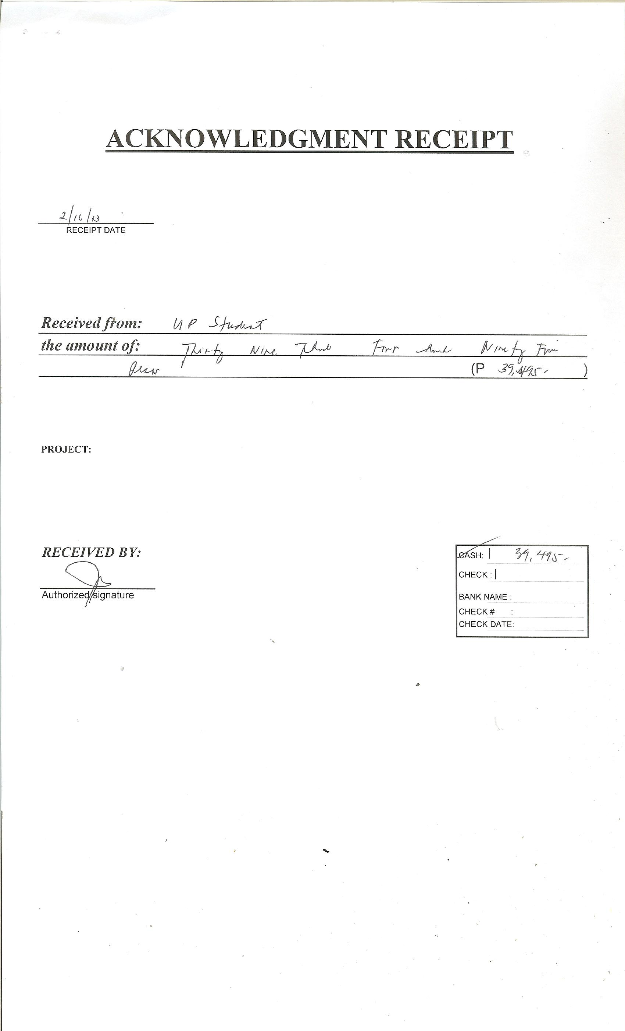
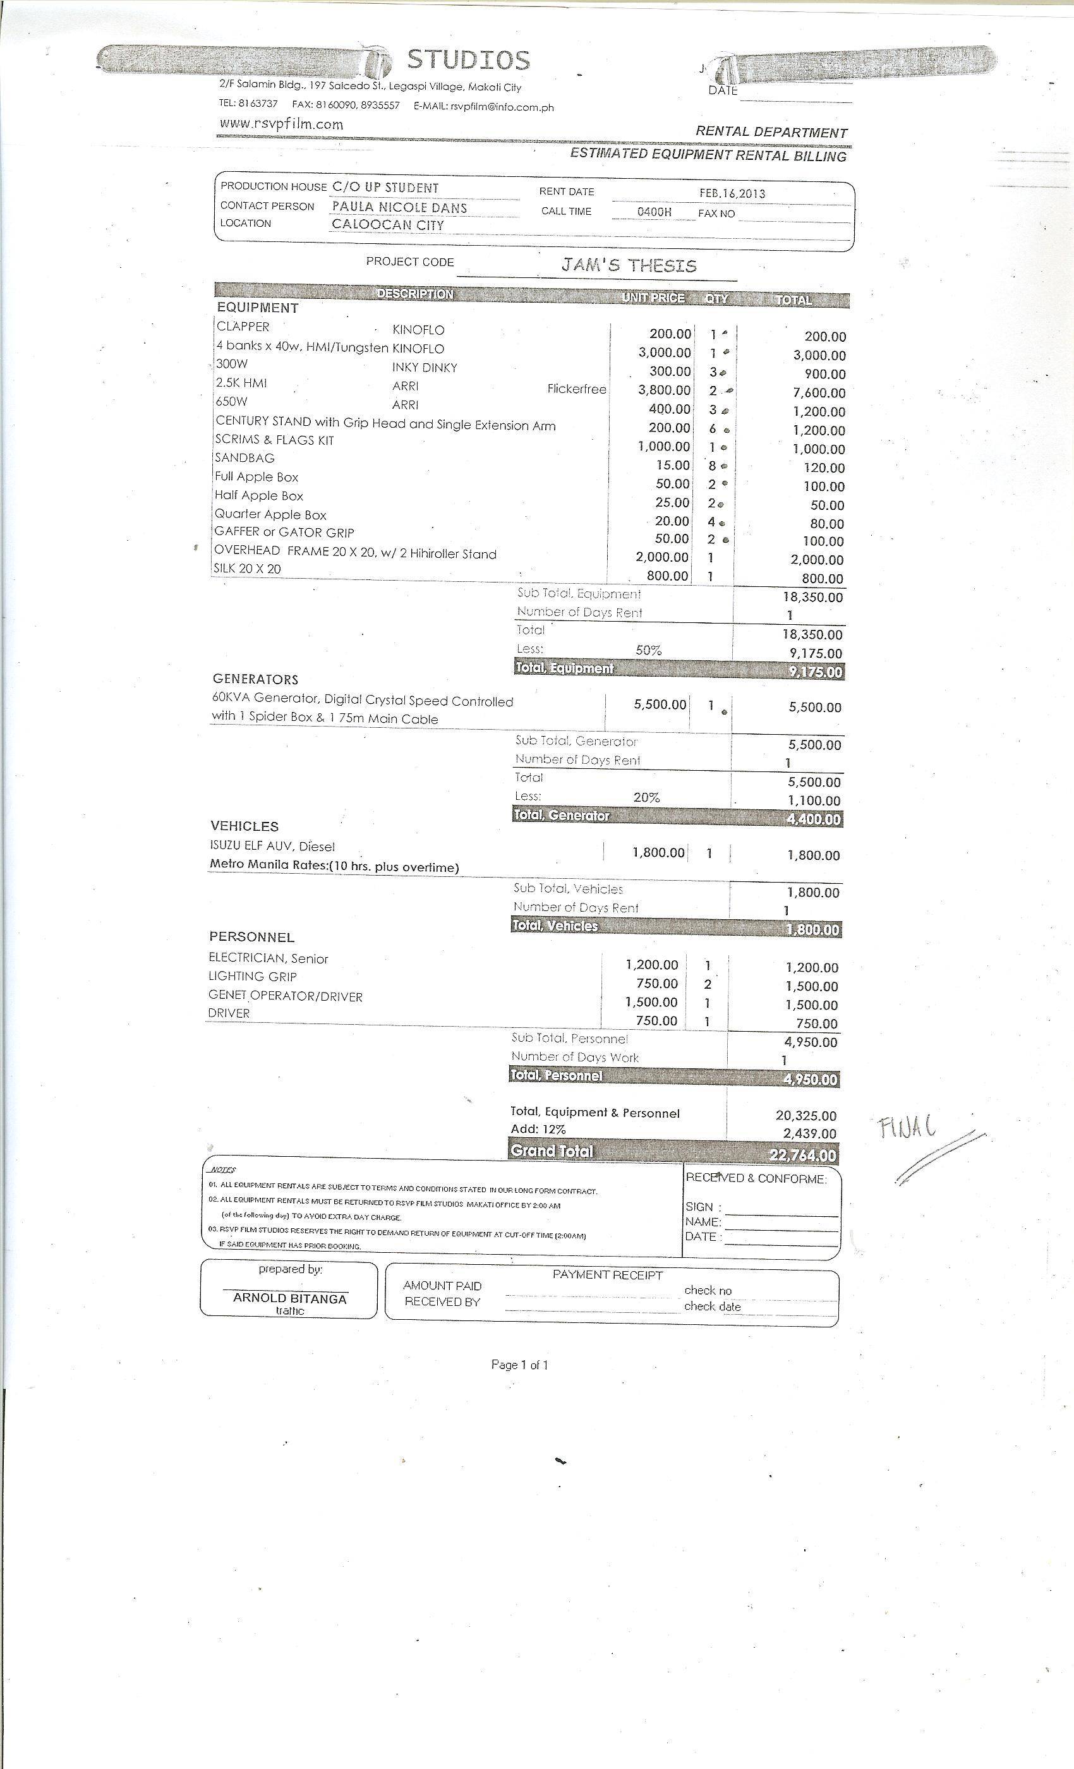
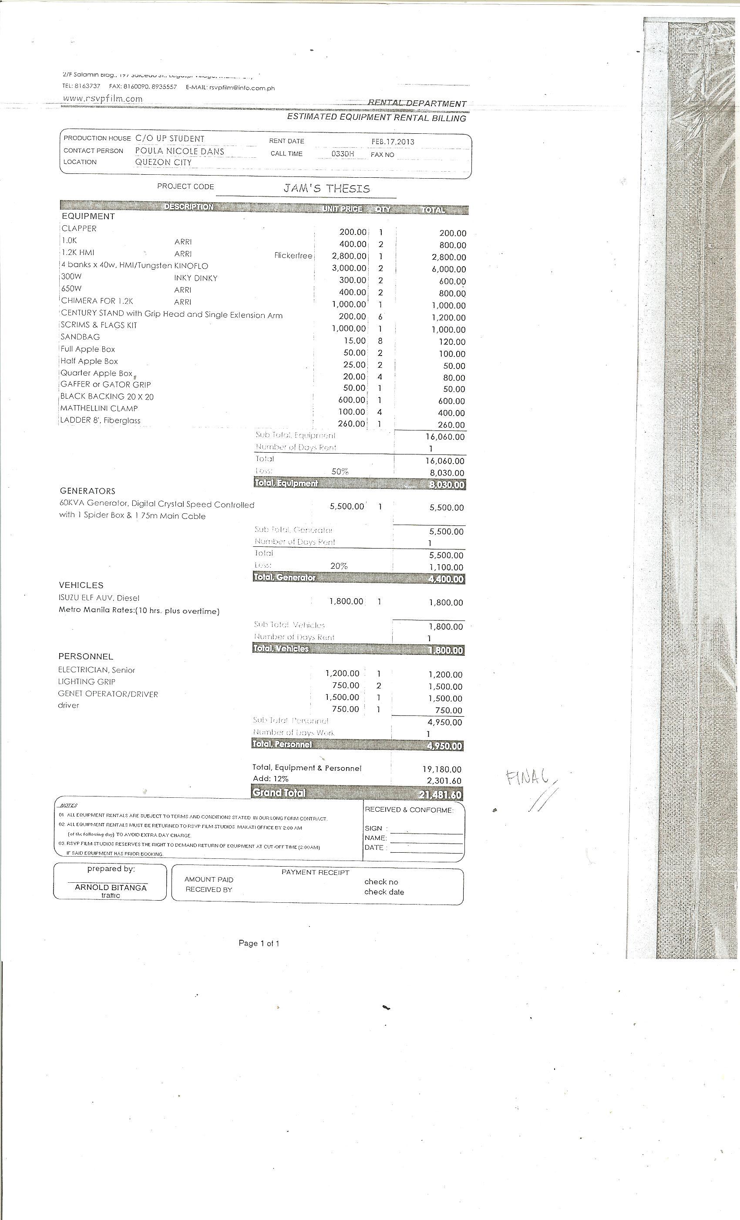


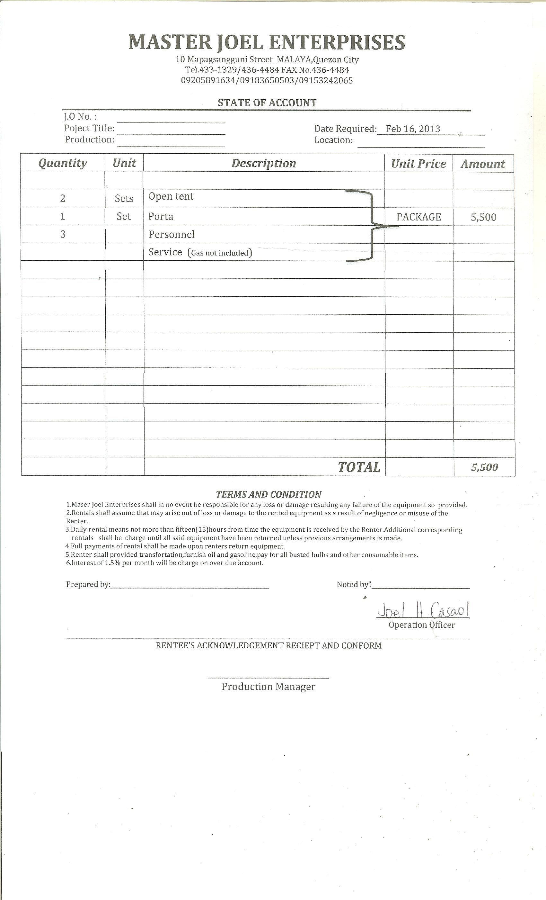

- Thesis Defense Forms


